What a busy week we’ve had! Pupils have been participating in Maths Week Scotland, doing lots of maths activities – check the photographs out on the SWAY link. We had a lovely day last Saturday with our past P7 pupils splashing and flying at the Galloway Activity Centre. Finishing off the week participating in ‘Just One Tree’ day event today.
Exciting times.
Mrs Fraser

WALK TO SCHOOL WEEK
5 - 9 October 2020
All the pupils will be taking part in this year’s Walk to School Week. We will be leaving the school at 9 am sharp and walking to Perchhall Cottage daily. Pupils will be accompanied by school staff every day. Slightly different routine from usual but the rationale is the same. – To promote a healthy lifestyle, now and for life!

JUST ONE TREE
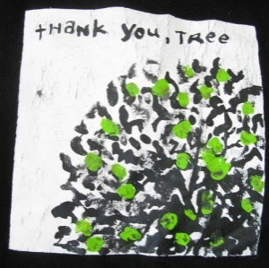
Thank you to everyone who either came along in a woodland colour or dressed as a tree. We managed to raise £21 which means there will be 21 trees planted on the partnerships behalf.
We all watched a film which told us all how important trees are in the living world.

Miss Bremner with the help of pupils planted our gorgeous tree in our playground which was kindly donated by a family from the school community.

Eco Committee

READY STEADY COOK
A reminder to send all your tasty recipes and photos to
apgparentcouncil@hotmail.com

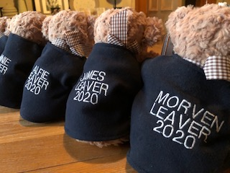
PRIMARY 7 CELEBRATION
It wasn’t easy to plan an event that captured Applegarth and Hutton ethos and was COVID-19 proof enough that allowed us all to be together.
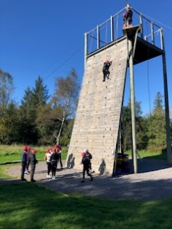
But…… we did it!

Primary 7’s enjoyed a wonderful trip to the Galloway Activity Centre as their ‘leavers celebration’. They went on a climbing wall, high wire and a very high swing! Each and every one demonstrated courage, humour and a very ‘can do’ attitude.

In the afternoon they put on their wetsuits
and went giant paddle boarding and flying down the waterslide. It was wonderful to see almost all our ‘old ’ P7 pupils. They seemed to have so much fun. Thank you to Miss Bremner, Mrs Black and Mrs Boyes for organising and supporting the event and to Miss Muir who came along to wave us off. It was great to be able to give our P7 an amazing celebration and send off - especially one that reflected the exceptional learning experiences they’ve gained throughout their school lives.

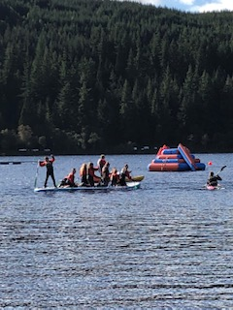
‘All the very best as you continue your learning journey’

PENCIL CASES
After the October holidays, pupils can bring their own pencil case for their own use. This must be kept at school in their trays and not taken home. Please note that this is not compulsory and it is the pupils’ responsibility to look after their items.

HOMELINKS
Please note -This is the last week for homelinks, please return these on Monday 5 October 2020.

This week’s SWAY features all the exciting activities our pupils have participated in celebration of Maths Week Scotland. Pupils have been very busy measuring speed, distance and time. Problem solving treasure hunt, self-portraits using shapes including exploring and finding maths in the place of work.

‘Phew a busy week.’
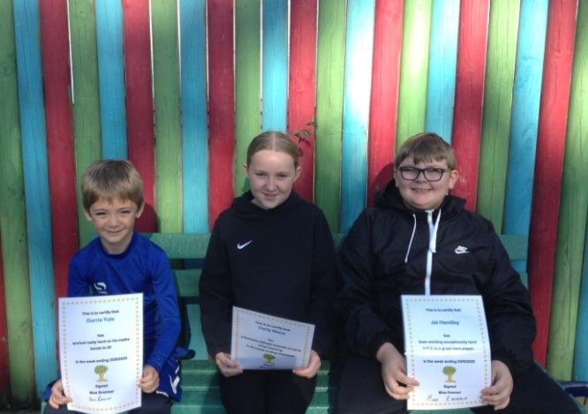
To view this week’s maths activities, just click the link.
https://sway.office.com/w3rUJKpBnRu1gx0L?ref=Link

MENU
There will be no change to the lunch menu. The current selection will run until Christmas.

MILK MONEY
If your child is entitled to free school meals this does not include the morning snack milk. Please send £1 per week if your child to receives this.

Please note – Only send in exact money for lunch and milk as change cannot be given, at this time. Thank you for your co-operation.

CERTIFICATE WINNERS
Well done Durrie, Carly and Jai.

