A few exciting things to look forward to this week. Our teachers are busy planning extra maths activities for all our pupils to enjoy. Great prizes to be won, so well worth taking part in the maths homework too.
In line with our Eco credentials we thought the ‘Just One Tree’ initiative was perfect for our pupils. As it is already a PE day we are asking our pupils to wear something green or brown or ‘tree ‘themed’ on Friday. Read on to find out more…..
Enjoy your weekend.

JUST ONE TREE

JUST ONE Tree is a non-profit initiative removing CO2 from the atmosphere through global reforestation. It’s simple - just £1 plants 1 Tree.

The first JUST ONE Tree Day in 2019 saw 80,000 children across 350 schools all uniting to help reforest our planet.
Together they raised enough to plant 100,000 trees in countries such as Madagascar and Kenya.

For one pound, a tree is planted in 7 developing countries - maximising the effect on cooling our planet whilst working with the local communities to prevent further deforestation.
This year Applegarth and Hutton Partnership Eco Committee are taking part by holding a non-uniform day.
To keep with the theme we are asking pupils to wear green or brown or branch out and come along ‘tree themed’ on Friday 2 October 2020. Recommended donation - £1.

£1 plants 1 Tree

MATHS WEEK SCOTLAND 2020
This Photo by Unknown Author is licensed under CC BY-SA-NC
(28TH Sept – 2 Oct)
Maths@Home Challenge!

Don’t forget to POST the details of your Maths@Home investigation on your Microsoft TEAMS Maths Homework channel ready for next week!!
Remember…..GREAT PRIZES FOR MOST DARING DETECTIVE WORK😊.

FLU IMMUNISATIONS
A reminder that the flu immunisations will
take place on Thursday 1 October 2020.

READY STEADY COOK

Following our Parent Council meeting last week, an enterprising parent had the bright idea of compiling all our family favourite Lockdown recipes and producing “Applegarth and Hutton’s Lockdown Cookbook”.
During the lockdown period pupils loved to escape their desks and continue their learning experience in the kitchen. Many families developed their cooking and baking skills whilst spending this time together. Some even headed outdoors foraging in the wood looking for the ingredients for their wild garlic and cheese scones. It would be great if everyone across the partnership could contribute some of their favourite recipes alongside a photograph or drawing of the ‘chef’ or dish. Please send your recipes into apgparentcouncil@hotmail.com.

CERTIFICATE WINNERS
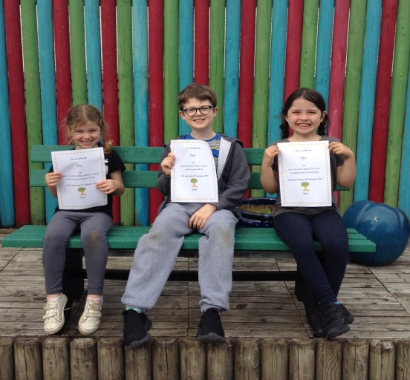
Staffing
Due to a change in circumstances, Mr Walker Jones will be remaining at Applegarth until the October holidays.

SWAY
Remember to view this week’s activities, just click the link.
https://sway.office.com/HNeyacSPGG74gJmn?ref=Link

Attachments and Enclosures
~AGM/ Ordinary Meeting Draft minutes and
Head Teachers/ Chairpersons reports are on the school website.

