What a beautiful sunny week.
We have had yet another successful week as we have moved on to extend our curriculum. The Parent Council met earlier in the week through ZOOM, look out for the draft minute and HT report on our website. Obviously there are restrictions on what we are able to do through the Parent Council fundraising activities at present but please do let us know if you have any fun suggestions.

Information in from…
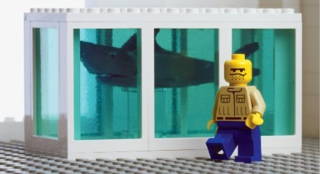

Gallery 2 : 1 October to 16 January
Lego exhibition
Lego girl
The Brick by Brick exhibition gathers the work of 18 artists, designers and photographers from around the world who use LEGO® bricks as their medium or inspiration. Using this simple plastic construction block as their starting point, they have created stunning, thought provoking and often humorous artworks which will appeal to art enthusiasts and LEGO® brick fans alike.

The exhibition includes a range of two and three dimensional work in a variety of scales and aims to showcase the different creative approaches that artists take when using this world-famous building brick.

This family friendly exhibition provides lots of opportunities for visitors to get involved with a quiz sheet activity, Lucy and Emmet photo booth, LEGO® brick mazes and a LEGO® book library and our online building self-portrait and mini figure competitions.

Please pre book your time slot for a visit on
www/DGCulture.co.uk or call the Mid-steeple box office.

APPLEGARTH
RAG BAG
Please help raise funds for your school by putting all your old items of clothing in our rag bag bin.
The next collection will be on 25 September – just in time for an Autumn clear-out!

MATHS WEEK SCOTLAND 2020 (28TH Sept – 2 Oct)
This Photo by Unknown Author is licensed under CC BY-SA-NC
Maths@Home Challenge!

Your mission should you choose to accept it……
ENCLOSURE: Secret Maths Mission.
This message WILL NOT self-destruct in 30 seconds!!
PRIZES FOR MOST DARING DETECTIVE WORK😊.

SWAY
Please click on the link below to access this week’s activities. Feel free to leave any comments or feedback.

https://sway.office.com/7EjK9XgcRyX98i5E?ref=Link

NATIONAL YOUTH ORCHESTRA SCOTLAND
Applications for the 2021 NYOS Classical and Jazz Pathways is open and there is still time to apply with the closing date next Friday (25 September).They are particularly interested to hear from oboe, bassoon, viola, brass and percussion players this year. There is no cost to audition and bursaries are available for all applicants.
Please follow the link if you need further information.
https://www.nyos.co.uk/members/apply

ONE WAY SYSTEM
The vast majority of our parents are loving our one way system and it has impacted positively keeping everyone safe in the current climate. However, it has been raised by the parent council and parents/family members that there are concerns that not all parents are following our one way system. Can we please ask in the interest of health and safety that everyone follow this procedure. If your child needs to exit the car from the passengers side onto the road please ensure you either assist your child if a staff member is not available.
The playground is supervised from 8.45am when possible.

It would be helpful if you collect your child/children as close to the allocated pick up time.
Please note the slight change of timings.
TAXI 3.05pm
P1-4 3.10pm
P5-7 3.15pm
Thank you for your ongoing cooperation.

STAFFING UPDATE
I am delighted to inform you that Mr Walker Jones has been successful in his application for another post, sadly this means he will be leaving us on Monday 28 September. I am sure you will join me in wishing him all the very best in his new job.
Please see the HT report which was shared at the parent council for further staffing updates.

INFORMATION SESSIONS
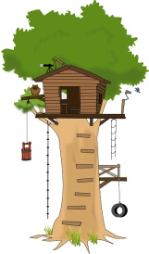
Following on from a discussion at our recent Parent Council meeting it was agreed that the school would make available information sessions through ZOOM.
Staff are hoping to run short information session which will also allow you the opportunity to ask any questions. We hope this way will be even more useful and accessible from the comfort of your own home. We are planning on providing sessions focussing on Literacy – which will include reading, writing, phonics and spelling, Numeracy, Renaissance Accelerated Reader and TEAMS in the first instance.
Please follow the link to complete the form if you are interested in attending and we will go with the most popular time and subjects.
Any suggestions for further sessions will be welcomed and considered.

https://forms.office.com/Pages/ResponsePage.aspx?id=oyzTzM4Wj0KVQTctawUZKUW24qU1tIVHikdiRiM0NrhUQjFJRzVDU0ZONVVQRUZVQzI1WE1ITzdLVC4u

LOOSE PARTS PLAY PLEASE
Loose Parts Play is when children are introduced to everyday objects to improve creativity, imagination and social and problem solving skills.
If you have any tyres, crates, wood, wood cookies, cones, natural items etc. you would like to donate to the school we would be most grateful.

TEAMS
I think we have almost all managed to access homework through TEAMS, if you are continuing to experience any difficulties – please do get in touch.

CERTIFICATES – well done!

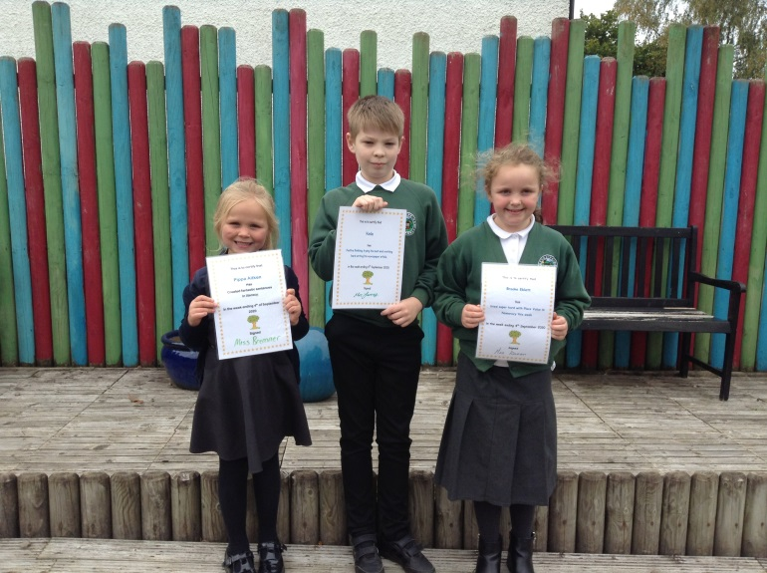
4 SEPTEMBER 2020

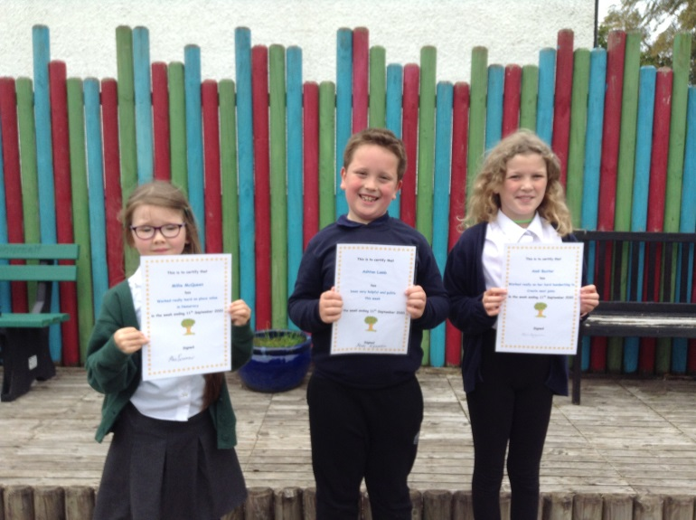
11 SEPTEMBER 2020

ATTACHMENTS/ENCLOSURES:
- Ragbag collection bag
- Secret Maths Mission

