Wow – half way through the term already! Time is flying past.
A few changes next week as we move on from the recovery phase by extending the curriculum and starting up homework again. We are here to support you in any way you may need us. Just let us know if you need help working with Microsoft Teams or any other matter.

Mrs K A Fraser

P1-4 CLASS ORGANISATION
Miss Keenan and Miss Bremner will Team Teach across the P1-4 class for the rest of the term. Working together across the stages will ensure continuity, progression and a high level of support from teaching staff.

HOMEWORK P1-7
As from this Tuesday, homework will be issued to pupils on a weekly basis via our Microsoft Teams tile in Glow. This will ensure we maintain our blended learning approach and are prepared for the future.
Each week there will be an active spelling task, set reading pages and a mathletics challenge within your ‘Teams’. There is also a termly new-look jigsaw, ‘The Rainbow Challenge’ where pupils can try to earn points and explore areas within their topic and wider learning.
Homework will be issued on a Tuesday and should be completed by Monday. Active spelling and Rainbow work can be photographed and uploaded to Teams. Reading books will be sent home every Tuesday and should be brought to school daily. Mathletics will be completed online.
Your child will be shown in class how to access their homework and upload their work to the site. They will also be re-issued with their login details. If you have any trouble accessing the homework, please let us know and we will do our best to support you. The attached ‘help sheets’ should also guide you in using Microsoft Teams if you haven't accessed it before.

Miss Keenan will also send a short information film to help explain TEAMS.
Thank you for your continued support and cooperation.

SWAY
Thank you to everyone who accessed our Recovery learning clip on Teams. We hope you enjoyed seeing all your children back at school and an insight as to what they have been busy doing. Please click on the link below to access the sway if you haven’t already and don’t forget to leave a comment on the ‘Recovery Team’ page or the website for pupils to read!
https://sway.office.com/sDTuRIClpYVgN7nk?ref=Link
Don’t forget to keep checking Teams or the website for future Learning Sways!

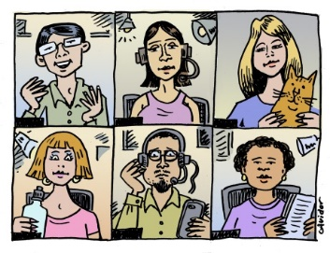
PARENT COUNCIL AGM & ORDINARY MEETING
Monday 14 September
6.30pm via Zoom

Thank you to everyone who has responded to the invite, a link will be emailed out to you on Monday to access the meeting.

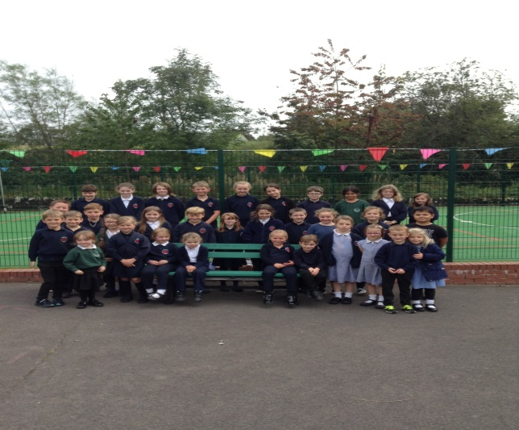

FRIENDSHIP BENCH
“A friend is a gift you give yourself”
Thank you to our Parent Council for the ‘Friendship Bench’ which has the very fitting quote enscribed on it. It sits proudly in the playground. We hope our pupils use the bench during playtimes either to relax or if feeling lonely.

FLU IMMUNISATIONS
For any parents wishing to seek further advice on the Flu vaccinations please visit the link below.
www.nhsinform.scot/childflu

P.E. KIT
Apologies for the change of instruction, we have found that due to time constraints pupils are taking a long time to change into their PE kit. As of next week, can all children please come to school in their P.E. Kits on a Thursday and Friday for the rest of the term. As P.E. may be outdoors please ensure your child/ren has warm clothing.

COVID – 19 TEST
If your child will not be attending school contact the office by 9.15am. Please let the school know if your child is being tested for COVID and then confirm the results. Thank you for the cooperation.

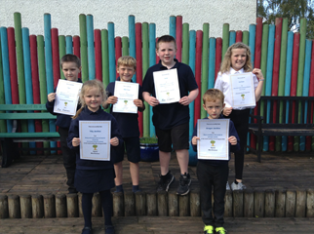
Congratulations to our certificate recipients Flynn, Tilly, William, Denzel, Gregor and Andi.

