We welcome 3 new pupils this week, Hadassah, Caleb and Emma. I’m sure you’ll join me in welcoming everyone into our community partnership.
We are looking forward to restarting our homework and expanding our curriculum next week. I’m proud of all the positive achievements of our pupils as they have returned safely back to school. Thank you for supporting us in their safe return.
Have a lovely weekend.

Mrs K A Fraser

CHECK IT OUT!!
Recovery Learning SWAY
We’ve put together a SWAY presentation of the Recovery Learning activities to share with you!
Please visit the RECOVERY LEARNING TEAM in Microsoft Teams or the school website with your child/ren and they can tell you about what they’ve been up to whilst you enjoy the photographs!!
The link below will take you straight to the page… RECOVERY LEARNING TEAM
Please feel free to share any thoughts or comments about the Recovery Learning period in the POSTS.
REQUEST FROM P5-7

Please can you send in any empty large plastic bottles you have on Monday 7 September. Thank you.

WASTE RECYCLING
If you are using the recycling bins at the school could you please try to ensure that only paper/cardboard is put into the correct bins. There have been occasions where the paper/cardboard bins are being contaminated with other waste which means the whole load needs to be disposed of differently. Thank you for your co-operation.
The ECO- Committee

SNACK AND WATER DETECTIVES
It has come to light that many of our pupils are bringing juice in their water bottles – can you please ensure your child has water in their water bottle.
We are a health promoting school, please take this into account when providing a small snack for break. Thank you.

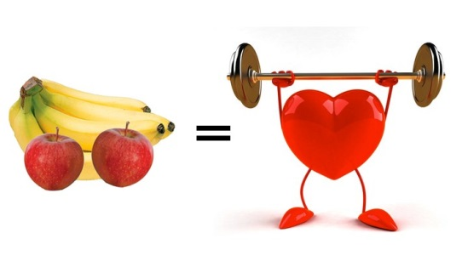

- Please return your flu immunisation letters completed.
- All Share Family Learning backpacks are to be returned to school.

