

Another successful week at Applegarth with our partnership pupils together. It has been such a delight to hear and see our pupils enjoy their learning indoors and outdoors this week as they continue to adapt back into school life. We will continue with our Hutton pupils at Applegarth for another week which allows us to teach across three classes.

Allow me to draw your attention to the Parent Council Meeting this term, you will find the details within the newsletter. We would love to see new faces as well as the ‘well kent ones’ at our AGM and our first meeting. You will be made to feel most welcome.

For our new families we try our best to only send letters and forms out on a Friday each week to be returned by Monday – hopefully this reduces the risk of missing a letter or the daily search for the a letter deep in the depth of your child’s school bag!

There are lots of forms to complete being sent home today – all forms returned for Monday would be most appreciated.

**SCHOOL LUNCH MENUS**

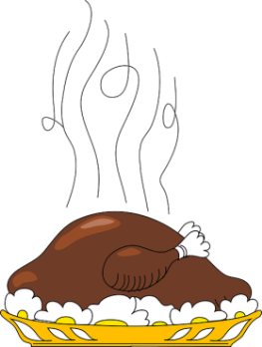As a wee reminder hot meals will resume next week. Enclosed in your letter bag you will find a copy of the menu choices your child has made (certain families only). Please enclose payment for meals and milk in the envelope provided, there is one envelope per family.



**DGHP FUNDING AVAILABLE**

DGHP  have been successful in obtaining funding from Corra Foundation Trust.  This money is for families in need and to help with any difficulties they may be experiencing with fuel bills, furniture, food or assisting with the kids education by way of lap top/tablet etc. etc..  To qualify, your family must reside and be a DGHP tenant.

If you think you may be qualify please contact the school office. Please note the deadline for this application is 31 August 2020.

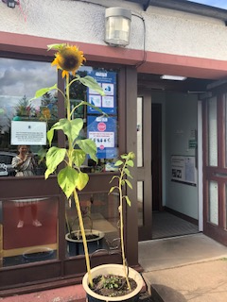**SUNFLOWER COMPETITION**

During our stay at home period Thomas and William Boyes initiated a Sunflower competition. For those of you who took part please can you send the measurements and photos that were requested to the school office. Good Luck, everyone!

**HARVEST TIME**

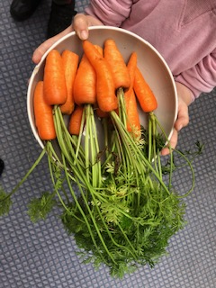We are absolutely delighted with our garden produce this year. Thanks to Mrs Boyes who took the pupils for gardening club last session. We have onions, carrots, beetroot and potatoes. Your child has received a gift of fresh vegetables to enjoy straight from the school garden. Enjoy.

**PARENT COUNCIL MEETING AND AGM**

**MONDAY 14 SEPTEMBER 2020 @ 6.30PM**

**C:\Program Files\Microsoft Office\MEDIA\CAGCAT10\j0185604.wmf**A warm invitation is extended to all parents and carers across the Applegarth and Hutton partnership who would be interested in joining our Parent Council. It is an excellent opportunity for you to become more involved with the school. If you are able to join via Zoom please complete the form. Details on how to join the meeting will follow.

**WORK FROM HOME**

We all know how much work was carried outat home during lockdown – whether it is photos of adventures or written tasks, art work, craft, outdoors or inside, we would love you to share it with us! Can all pupils bring in their work – a sample is sufficient if it is too heavy to carry. Photographs to the school office email address.

Thank you.

**Pupils Safe and Responsible Use of Technology Agreement (including Online Learning)**

Enclosed you will find a copy of the Pupils Safe and Responsible Use of Technology Agreement. You will note that this document includes a consent form in relation to recording (Appendix 1(b)) even although this function has not yet been activated by Teams. The reason for this, is to future proof the guidance especially in relation to blended learning opportunities.

**BE PREPARED FOR ALL WEATHERS**

Can all pupils please bring a rain jacket and wellies regardless of the weather forecast. These can remain at school in a carrier bag on their peg if you prefer.

**P.E.**

As current guidelines have now changed, pupils can change into their PE kits at school. All pupils should now come to school in their uniforms and bring their PE Kit with them in a separate carrier bag. PE kits can be left at school for the term. Please ensure your child has suitable trainers for PE outdoors.



**SWAY**

Our first weekly SWAY to share pupil learning experiences as they transition back to school will be available on Friday 28 August once we have received photo permission.



**LETTER BAGS**

At the start of every new academic year we are required to update information we hold on each child. There are a number of forms that need your attention and would appreciate if these can be completed and returned by Monday 24 August 2020.

Forms enclosed in the letter bag are:

* Annual Data Check
* Image Consent (certain pupils only)
* School Trip Medical
* Blanket Consent
* Intimate Care (P1)
* Transport to and from School
* Use of Technology Agreement
* Menu Choices (certain families only)
* Parental Permission Medical (certain pupils only)