Well done everyone as we approach the end of Week 3. For stability and predictability in these uncertain times we have made arrangements for all our pupils to continue at Applegarth up until the October holidays. This benefits us greatly with flexibility of staff, stage to stage working and small ratios. Thank you for your continued support.

Mrs K A Fraser

SUNFLOWER COMPETITION
Congratulations to Finley and Jasmine on winning the Sunflower competition. Your prize is on its way.

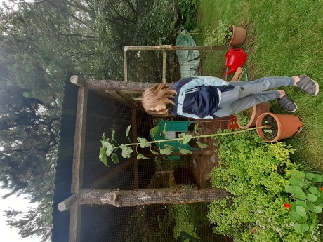
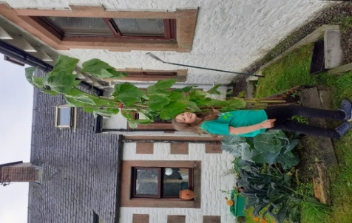

KAPLA TOWER
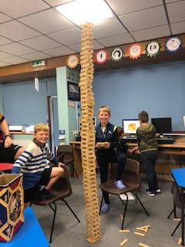
We have a new school record. Well done to William and Howie, with additional help from Mr Walker Jones to reach the top.

NON ENTITILED SCHOOL TRANSPORT
Applications are now being taken for non-entitled school transport requests.
Discretionary School Transport may also be available for pupils who meet ALL of the following qualifying criteria:
- Pupil lives more than 2 but less than 3 miles from school
- Pupil attends catchment school
- Pupil is in receipt of Free School Meals
- Pupil has previously been declined for “grace and favour” transport
Please contact the school office for application forms.

All young people over the age of 5 who use school transport to get to and from school will also be expected to wear a face covering. The face covering is required to be worn for the full journey.

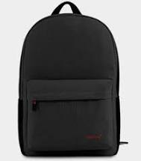
APPLEGARTH FAMILY LEARNING BACKPACKS (black bags)
Pupils in P5-7 should return the bags to school as soon as possible. Thank you.

ECO Committee
We hope you enjoyed our school grown vegetables that were sent home last week. As we also have apples, raspberries and blackberries growing we often like to share these with the pupils during the school day. To check no one has any specific allergies we are not aware of, we require your permission to allow your child to pick and eat them. Our fruit is all organic and has not been treated with any chemicals. Please complete the form via the link to give your consent. Thank you.

LET’S GET COOKING FACEBOOK LINK FROM the hEALTH improvement TEAM

The Health Improvement Team are currently promoting cooking from scratch via a new initiative 'Let's get cooking at home'. To date this Initiative has been promoted through the local SHAP (Safe & Healthy Action Partnership) facebook page and we appreciate that some of you may not be members of this partnership or may not have seen these posts on facebook, therefore I have provided links below for all the posts to date.

Each week we are posting recipes and practical videos to provide inspiration/guidance on how to make best use of store cupboard ingredients and how to cook nutritious meals and snacks on a budget as well as encouraging families to get cooking together. Please note Week 1 provides an overview of the Initiative, including a family meal planner, kitchen equipment list, store cupboard ingredients list and links to guidance on nutrition for the early years.

Any feedback/comments you have regarding Let's Get Cooking Facebook page would be much appreciated.

Many thanks in advance for your support!
Yvonne McGregor
Health Improvement Worker
Week 1:
https://www.facebook.com/1142268205795905/posts/3383270978362272/
Week 2:
https://www.facebook.com/AandESHAP/posts/3405153269507376
Week 3:
https://www.facebook.com/AandESHAP/posts/3421652667857436
Week 4:
https://www.facebook.com/AandESHAP/posts/3442473775775325
Week 5:
https://m.facebook.com/story.php?story_fbid=3461609737195062&id=1142268205795905
Week 6:
https://www.facebook.com/AandESHAP/posts/3482690075087028
Week 7:
https://www.facebook.com/AandESHAP/posts/3502200399802662
Week 8:
https://www.facebook.com/AandESHAP/posts/3520541897968512
Week 9:
https://www.facebook.com/AandESHAP/posts/3541752742514094?__tn__=K-R
Week 10:
https://www.facebook.com/AandESHAP/posts/3564313473591354?__tn__=K-R
Week 11:
https://www.facebook.com/AandESHAP/posts/3582618251760876?__tn__=K-R

FLU IMMUNISATION
This will take place on Thursday 1 October for both schools. Enclosed you will find a consent form and information leaflet. Please return consent form on Monday 31 August.

REMINDER
A wee reminder to return the various forms that were sent home last week. These should be returned by Monday 31 August to ensure the school has the most recent contact information and consents.

Enclosures
- Flu Vaccinations Letters
- NEP transport form (selected parents)

