RAINBOW DAY
Team: AppleHut Extra |  | Week: Wednesday 01-07-2020
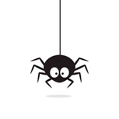  Numeracy  Problem Solving  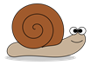  In my garden I have ants, snails, birds and spiders:  - Ants have 6 feet  - Snails have 1 foot!  - Spiders have 8 feet  - Birds have 2  I can see 30 feet and 8 heads. How many of each creature do I have in my garden?  Share your solutions on Teams or by email. REMEMBER TO USE LOGIC, MAKE A MODEL IF IT HELPS AND RECORD SYSTEMATICALLY! | Under Construction!!  This Photo by Unknown Author is licensed under CC BY-SA  Make a Rainbow Spinner  To show how white light is made up from a spectrum of coloured light!  Rainbow Colour Spinner Experiment  Instruction Video  HEALTH & SAFETY!  As with any Science experiment remember to work safely and ask for adult help for cutting etc. if you need to.  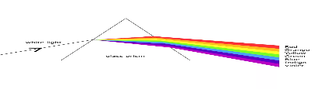 | 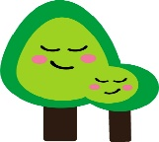  STEM: How does a leaf breathe???  This Photo by Unknown Author is licensed under CC BY-ND  Save this experiment for a sunny day when you have time to observe!  Find instructions using the links below…  Do Leaves Breathe Experiment?  (Extra ‘Praise’ if you can spot the spelling mistake on this webpage!!)  Do Leaves Breathe Experiment guide & explanation  Do Plants Breathe Experiment Video.  Remember to take photographs to share the results of your experiment!
HEALTH & WELLBEING  Take a breath…  Watch this & use video…  Rainbow Breathing  Or print off the Triangle Breathing sheet with the grid on the website to guide you.  You could try to hold your favourite Garden or Animal Yoga posture whilst Breathing!  This Photo by Unknown Author is licensed under CC BY-SA | Storytelling Stones  - Find some smooth stones or pebbles.  - Cut out pictures & use PVA glue to stick them on, adding a final layer of glue to varnish them.  - Or use acrylic paints or permanent felt-tips e.g. Sharpie pens to decorate – these can be varnished with PVA too.  - You will need stones with characters/settings/problems/events/solutions/other objects e.g. a Rainbow or magic wand….  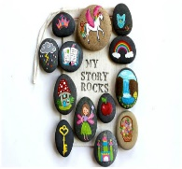  - Find a special pouch or box for storage!  Use the links below for inspiration….  Story Stones - Instructions  How to Make Story Stones Video Short video story example…and don’t forget to video & share your stories! | Rainbow Languages  La Rayuela (Hopscotch)  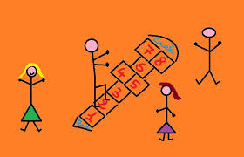  Use the links below to find out how to play…  La Rayuela La Rayuela in Spanish!  Use chalks or sticks to mark out a grid.  Teams Bremner & Keenan: Practise numbers to 10 in Spanish. Use the links below to help…  Count to 10 in Spanish  Count to 10 in Spanish - Forward and Backwards!  Team Muir: Can you challenge yourself by writing the Spanish number names, perhaps using larger numbers or counting in tens in Spanish!! Use this link to help… Count to 100 in Spanish!  EMPEZAMOS!!

