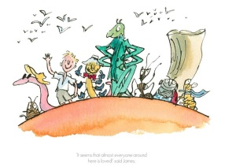
RAINBOW Week – DAY 2 Tuesday
STEM Challenge- Maze Making  In a safe space outside create a mini bug maze. Using things you can find outside make the walls of your maze. (Your walls don’t have to be tall.) Make sure to include dead ends to trick your bug!  - Challenge 1 – Create a maze where the bug has to travel from one side of the maze to the other.  - Challenge 2 - Create a maze where only one path makes it to the middle.  - Challenge 3 - If you have a big space make a maze for a sibling, pet or grown-up! | Literacy – Story Settings  Think of your favourite story and where it is set, it could be the peach from James and the Giant Peach or it could the garden of the Very Hungry Caterpillar.  - Miss Bremner’s Team – Draw the setting of your very favourite book.  - Miss Keenan’s Team – Write a postcard imagining you are on holiday in the world of your favourite book. What can you see? Who do you meet?  - Miss Muir’s Team – Create a set of 8 clues about your favourite book’s setting. Share the clues and see if Mrs Shenton-Ross can guess the book! | ECO Challenge – Water Wheel  You will need – a paper plate / circular cardboard, some small cups or bottle tops, a stick, a tub and some water.  Follow the instructions below to create your own water wheel.  **Your AppleHutt Challenge is to make as much of the water wheel out of recycled material as you can!**  Remember to share what your creations!  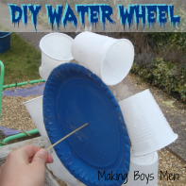  Water Wheel
Health and Wellbeing – Rainbow Dancing  When our bodies are active our minds are too. Get your blood flowing by having a dance!  - Miss Bremner’s Team and Miss Keenan’s Team can try this Video  - Miss Keenan’s Team and Miss Muir’s Team can dancing to this video | Art – Big Mouth Monster!  You will need – a piece of paper, colouring things and your imagination!  Follow the instructions on the video below and please share your sweet and scary creations!  Big Mouth Monster | Numeracy - Number Hunt  Numbers are all around us, on our doors, on our TVs even sometimes on packets of our food!  - Challenge 1 – Photograph any numbers you can find around your home.  - Challenge 2 – Can you find numbers 0 -100 written in your home or garden? Photograph and share your findings!  