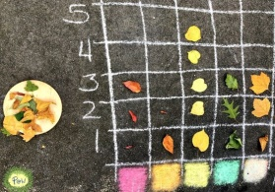  Maths - Outdoor Data Handling!  Data is information and there are lots of ways to display information.  Challenge 1 – Collect 10 things from outside. Either put them into the example Venn Diagram or create your own Venn diagram. Remember if something fits in both circles it goes in the middle!  Challenge 2 – Collect 15 things from outside, some of them can be the same. Create a pictograph with your collection like the picture above. Remember the numbers up the side!  Challenge 3 – Collect 20 things from outside and make your own graph or chart to display what you found! | Outdoor Hapa –Zome  You will need – a piece of cloth/ paper, kitchen roll, moist flowers and leaves, a small hammer or a spoon.  - Place the piece of paper on a smooth surface.  - Arrange your flowers/ leaves on top.  - Place the kitchen roll on top.  - Gently hit the leaves and flowers with the small hammer/ spoon.  - Peel away the kitchen roll.  - Ta- Da! You have a picture!  Hapa Zome instructions 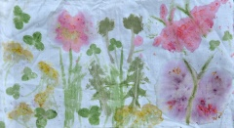 | Literacy – Great Garden Words!  Miss Bremner’s Team – Draw a picture of your garden or outdoor space. Then think of 3 words to describe your garden.  Miss Keenan’s Team – Look, listen and smell your garden and think about all the words to describe it. With your words create a special garden word search. Use a minimum of 10 words!  Miss Muir’s Team – Choose 15 - 20 words which describe your garden. With these words create a glossary. Try to pick the best wow words you can think of!  Blank Wordsearch
STEM / ECO - Mini Pond  You will need - a small container, twigs and leaves and some gravel or small stones.  Please photograph and share your creation!  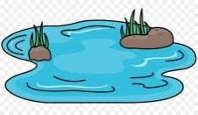  Instructions  Video | Genius Hour  Spend an hour of your time, researching, playing, talking about or watching something you are really really interested in.  Follow the link to Mrs James’s SWAY for more details SWAY | Health and Wellbeing – Amazing You!  You are a fantastic person! Can you think of something amazing about you for each colour of the rainbow?
RAINBOW Week – DAY 1 Monday

