RAINBOW DAY
Team: AppleHut Extra |  | Week: Friday 26-06-2020
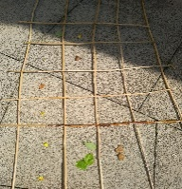  Nature Suduko  Problem Solving!!  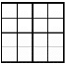  You can use chalks or sticks to create your Suduko grid.  For a 4 x 4 Grid you will need…  - 4 of each item: e.g. Daisy/Leaf/Stone/Buttercup  CAN YOU SOLVE THE PUZZLE? You need 1 of each item in each…  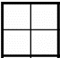  Row Column  and 2x2 box  Team Muir Challenge: Try a 6 x 6 Grid for someone to complete or perhaps get someone to make one for you?!  Teams Bremner & Keenan: You might like to try the cut & stick sheets instead. | 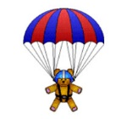  Eco Construction!!  This Photo by Unknown Author is licensed under CC BY-SA-NC  Make a Parachute  Reuse & Recycle materials that you have about the house to make & test a parachute – you could use a paper napkin or a plastic bag.  How to make a parachute Video  And here’s the Science about air resistance/drag…  Parachute Physics for Kids | STEM: I can see a Rainbow…  To see a rainbow you will need:  - Empty paper towel roll  - Craft knife and/or scissors (Adult help needed)  - Blank or old CD (check first!)  - Pencil  - Small piece of cardboard  - Tape  - Paint (optional)  Use the link to find step by step instructions…  Homemade-spectroscope  OR if it’s super sunny and you have a garden hose or sprinkler & willing adult helper you could try this…  https://childhood101.com/make-a-rainbow/  How to Make Rainbow - Video
HEALTH & WELLBEING  Take a breath…  Watch this & use video…  Square Breathing  Or print off the Breathing sheet with the grid on the website to guide you.  You could try to hold your favourite Garden or Animal Yoga posture whilst Square Breathing!  This Photo by Unknown Author is licensed under CC BY-SA | Wonders of Nature  Find ‘something’ natural and interesting or beautiful outside in your garden, on a walk or looking out of a window!  - Use all your senses if you can – sound, touch, sight, smell & taste (if it is safe!!)  This Photo by Unknown Author is licensed under CC BY-SA  - Explore as many adjectives or descriptive phrases as you can to describe your chosen item – be super creative!!  - Use the link below to create ‘WORD CLOUD’ about your chosen natural object – can anyone guess what you are describing?  Worditout - Word Cloud Creator | Rainbow Languages  ‘La Marelle’ (Hopscotch)  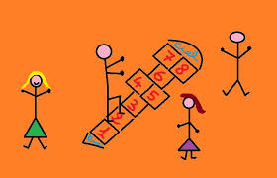  Use the link below…  How to play La Marelle  Use chalks or sticks to mark out a ‘Marelle’ grid.  Team Keenan: Can you count from 11 -20?  Team Muir: Can you challenge yourself by writing the French number names, perhaps using larger numbers or counting in tens in French!!  un dix  deux vingt  trois… trente…  French Numbers 1 - 20  Everyone's Favourite French Number Song 1-100

