Key Learning Tasks
 |  | Team: Miss Bremner
Literacy:  https://www.youtube.com/watch?v=y_O7cJjZM9g  Listen to the story ‘The Star of the Zoo’ and redesign the front cover to show who really is the star of the Zoo | Numeracy:  Design a castle out of recycled materials.  Identify the different shapes you have used in your castle.  How many shoes high is it? | Topic  Go on Safari  Watch the video and draw a picture of your favourite animal.  https://youtu.be/rULwnYPnfxE
French  Learn the French for some common zoo animals by following this link.  https://www.youtube.com/watch?v=OjY-lXmAGKI  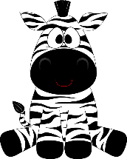 | Literacy:  Think of five lockdown memories and write them down. What was your favourite activity to get up to? | Numeracy:  Revise your number bonds by playing on top marks  Follow the link  https://www.topmarks.co.uk/addition/robot-addition  