Team: Apple Hut Extra | Week: 10 Thursday 25-06-2020
Art: Create an Origami Frog.  Follow the instructions in the links below and just use any kind of paper you have in the house – you will need a ruler & Maths measure skills to make it 15cm x 15cm – or any square – you could make a different sized family of frogs!  Miss Muir’s Team try…  Origami Frog Video  Miss Keenan’s & Miss Bremner’s Teams try…  Simple Frog with printable paper & Video  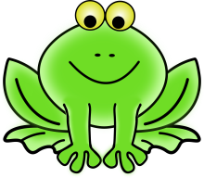  See if you can make your frog jump outside! If you make one each you could have a Frog Family race!  Remember to video your Frog or Race! | Literacy: Super Grown-Ups!  Pick a grown up in your house and turn them into a Superhero!  - Create a fact file all about your Super Grown-Up!  - What would be their superpower…making delicious meals at lightning speed or giving the strongest hugs in the world?  - Make sure to give them a ‘supersuit’ too!  OR Miss Keenan’s and Miss Bremner’s Teams use the Templates included on the school website! | Health & Wellbeing:  Train your Memory!  - Put 7 things (they can be anything) in a line.  - Look at the things for 30 seconds then cover them over with a cloth or blanket.  - Can you remember all 7?  Miss Keenan’s team try 9 things!  Miss Muir’s teams can you try 12 things?  CHALLENGE: What is the maximum number of things CAN you remember?!
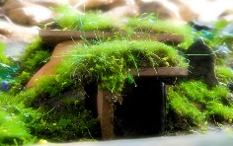  STEM/ ECO CHALLENGE  This Photo by Unknown Author is licensed under CC BY-NC  With things you can find outside or things which you can recycle from your house, create a house for a Fairy or a Gnome.  It must have a roof and a door so the Fairies/ Gnomes can keep dry. Remember to build it in a safe space.  **As an extra challenge try to make it waterproof & test it by recreating a rain shower with a watering can!!**  Take photos as evidence and share them. | Numeracy: Hunt for Right Angles.  We know that a Right Angle is 90 degrees, like a corner.  Can you find things outside or inside which are right angles? You can use the Right-Angle Eating Monster with this Grid.  Miss Keenan’s & Miss Muir’s Teams:  - Can you find and name any other types of angles? e.g. ‘acute angles’.  - Remember to photograph your angles with their names! | Spanish: El Arco Iris  - Print off & cut out the sheet with this grid.  - Either stick onto an egg box or copy the information on the sheets onto an egg box.  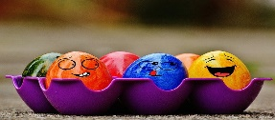  - Then take your Egg Box Treasure Chest on a Spanish Rainbow Colour Treasure Hunt!!  Use the link below to hear how to say each colour of the rainbow in Spanish….  Spanish Rainbow Colours Song
RAINBOW DAY

