Key Learning Tasks
Team: Miss Bremner |  | Week: 18/06/20
Literacy:  Recreate your favourite books front cover. Listen to the video to find out more  https://www.youtube.com/watch?v=mI3E9B6he8w | Numeracy:  https://www.topmarks.co.uk/maths-games/hit-the-button  Have a go at doubles and halves this week | Art  Make a Disney Villains Mask  https://youtu.be/12-UixJvAQE  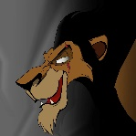 | PE:  Take part in a Disney Dance-a-thon  Pop on your favourite Disney songs and have a boogie!
HWB  Disney Think about the different Disney films you have seen. What kind of food would you like to try from one of the movies? Would you eat Aurora’s birthday cake? Or Ratatouille’s pasta dishes? Could you try some of Timone and Pumba’s bugs? Or go to the Mad Hatter’s Tea party? Draw you eating something Disney and delicious! | Literacy:  Can you make an invite to ask the tiger to tea? You will need to make a shopping list to decide on what you will need for your tea party.  https://www.youtube.com/watch?v=n53ox6rW82Y  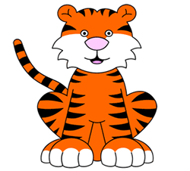 | Numeracy:  20 something pictures  Use only 20 objects to make a beautiful picture  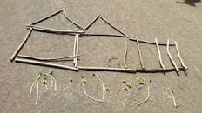 | French  https://www.youtube.com/watch?v=pfShW_Y68_w  Listen and enjoy the Lion King Hakuna Matata in French

