L’arc en ciel  The rainbow | rouge | orange | jaune | vert | bleu
indigo | violet | or | Argent | Quelque chose de special…  Something special… | Quelque chose j’aime…  Something I like…

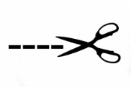
Cut these out to stick onto an egg box and add the colour using felt tips to help you if you wish.
Then gather your French colour treasures!
You can use a dozen (12) egg box or 2 x ½ dozen (6) egg boxes – just cut along the thicker black line in the middle!

