RAINBOW DAY
Team: Apple Hut Extra | Week: 9 Friday 19th June
Literacy  Compliments task.  Write a postcard to someone you know with two compliments for them. These can be nice things which you admire and like about them. How does it feel to send nice things to someone?   | STEM Challenge: Pizza Box Oven    ADULT SUPERVISION REQUIRED FOR CUTTING!!  This Photo by Unknown Author is licensed under CC BY-SA  Find out how using these links…  VIDEO - How To Make a Pizza Box Oven  Science Buddies Pizza Box Oven VISUAL Instructions  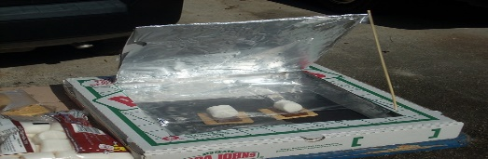  Or PRINT OFF THE PDF which accompanies this grid.  This Photo by Unknown Author is licensed under CC BY-SA | Numeracy: Building Kites  What you will need: paper, straws or thin pieces of wood, string/wool/ribbon, scissors, paste, pencil, sticky tape and a ruler  What to do:  - Draw a kite shape on your piece of paper.  - Measure your kite length and width.  - Then cut the straw/ wood to the right length.  - Stick on the 2 pieces of wood (or straws) perpendicular to each other using the tape.  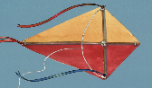  - Decorate your kite.  Or you could check out this link for a picture guide…  How to make a Kite  Attach the string to the kite and take it outside to see if it will fly!
Garden Yoga  Spot the different shapes that are outside your house and see if you can make your body into the same shape.  - Can you stretch like the tree?  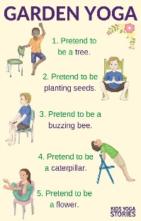  - Or curl up like a bush?  - Can you make yourself flat like a gate?  - See if you can do this for 6 different shapes. | L’Arc en Ciel  - Print off & cut out the sheet with this grid.  - Either stick onto an egg box or copy the information on the sheets onto an egg box.  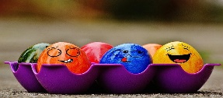  - Then take your Egg Box Treasure Chest on a French Rainbow Colour Treasure Hunt!!  - Can you find something for each section of your egg box? | Art  How many shades of green can you find? See how many different green things you can find outside. Are they all the same shade of green or are they different?  Take photographs or draw & colour to record your finds!

