Team: Apple Hut Extra | Week: Thursday 18th June
Literacy Wooden Spoon Characters  What you will need- A wooden spoon, different materials, pens, wool and your imagination!  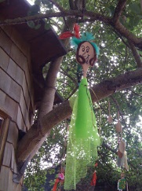  Design clothes and a face for your wooden spoon. Then create your character!  Extra challenge: Write a story about your wooden spoon character – what will they get up to…? | Numeracy: Daisy foot prints  Have you ever thought about how many plants/daisies you stand on with every step you take?  Well, today we are going to work it out!  - You will need a piece of cardboard, a pen , scissors and your foot  Draw round your foot on the cardboard and cut it out,  Take the ‘footless’ piece of cardboard out onto the grass and set it down.  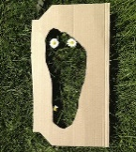  Count how many different plants you would be stepping on. Luckily for us grass and daisies like to be trodden on and it can help them to grow. Phew!! 😊 | STEM: Make a Stick Maze  You will need:  - lots of long sticks OR household items (WITH PERMISSION!) can be used if no sticks available  - a piece of paper to plan your maze  What to do:  1.Draw your maze (basic is better)  2.Collect materials to make your maze  3.Make your maze following your plan  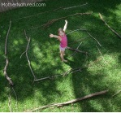  4. If you need to readjust your plan that is okay!  Or use this link  Make a Stick Maze  Now try out your maze!
Art  Think of one wish.  Create a picture of your wish using things you can find outside. My wish would be that I could go to my favourite place in the mountains with my dog.  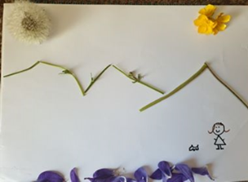 | Health and Wellbeing…  - Sit outside in a safe place for 10 minutes with your eyes closed.  - Pay attention to all the things you can hear.  - Can you hear people or traffic?  - Can you hear different birds?  - See if you can hear over 10 sounds! | Eco Make a Bird Kebab  (hens love these too!)  You will need:  Apples, Bread, Hard cheese(cheddar), Raisins, Wire or String  What to do:  Cut the apple, bread and cheese into block shaped pieces which you can thread onto the wire.  Hang in your garden or within ‘pecking-reach’ if you have hens!  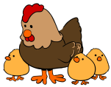
RAINBOW DAY

