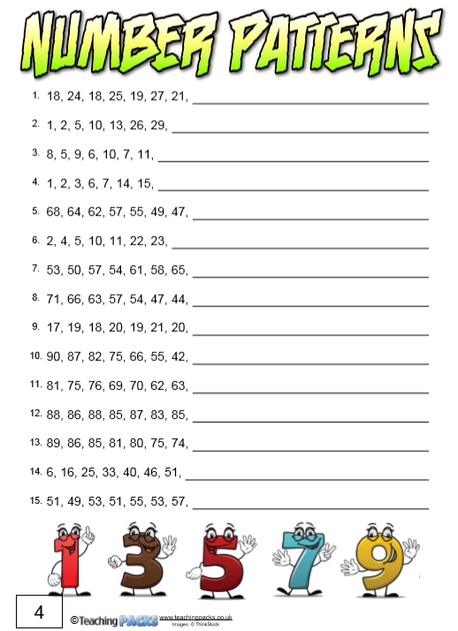
Can you work out the pattern? There may be more than one process taking place (I have put the solution to number 1 in the text box so that you can see an example). Once you know the rule, work out the next 4 numbers in each sequence. There are 15 questions but please don’t feel like you need to try them all. You can type into the boxes at the side of each question or you can write your answers on paper.
- 30, 24, 34, 28

So far, the rule is: +6, -6, +7, -6, +8, -6
The number that is added on is increasing by 1 each time. That means that I need to +9, then -6 again and then +10 and then -6.

