Recipe for Success:
-I can estimate the length of ocean creatures in metres and centimetres.
-I can measure out the length of the creatures using a homemade metre stick.
-I can compare the lengths of the ocean creatures with different objects.
-I can convert between different units of measurement.
Have a little look at the pictures of the different ocean animals below. How long do you think each of the creatures will be in metres and centimetres ? Write your guess down.
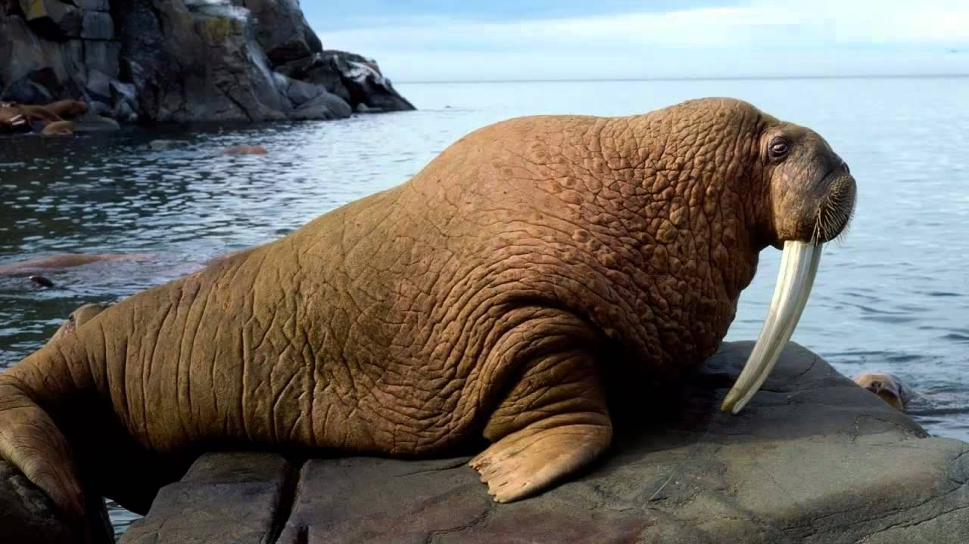
This is a Walrus.
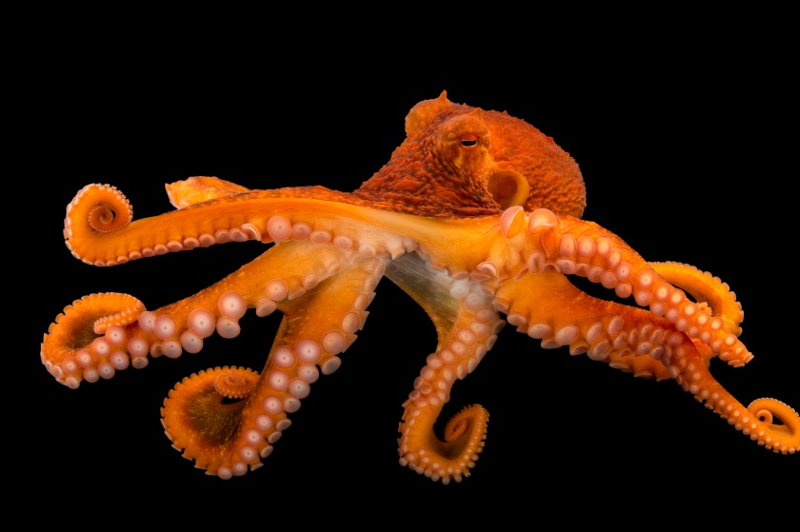
This is a Giant Octopus.
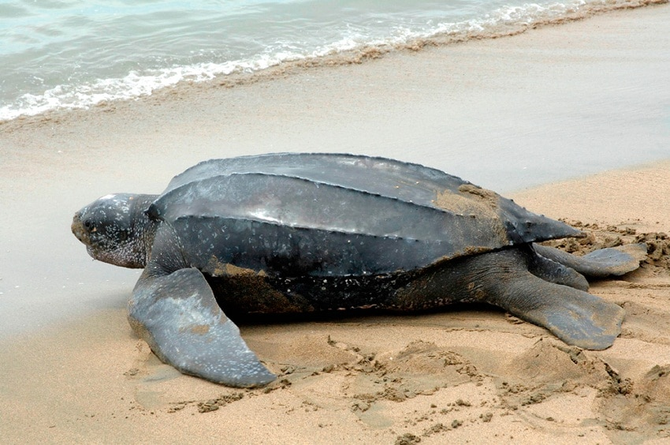
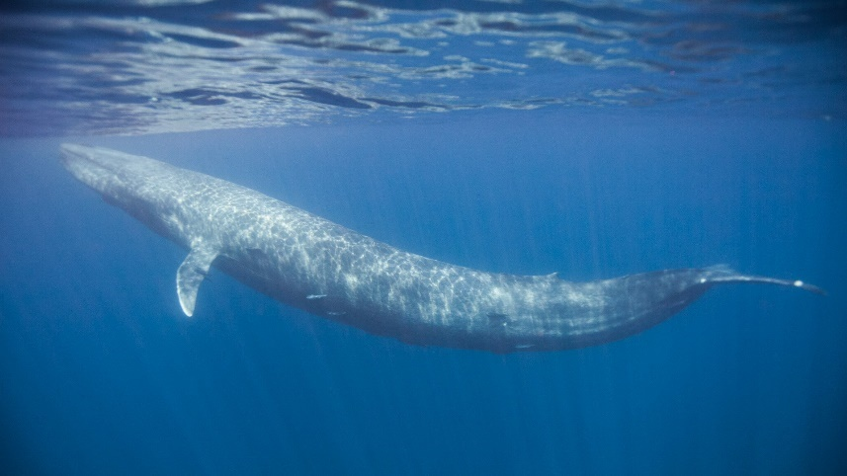
This is a Leatherback Turtle.
This is a Blue Whale.
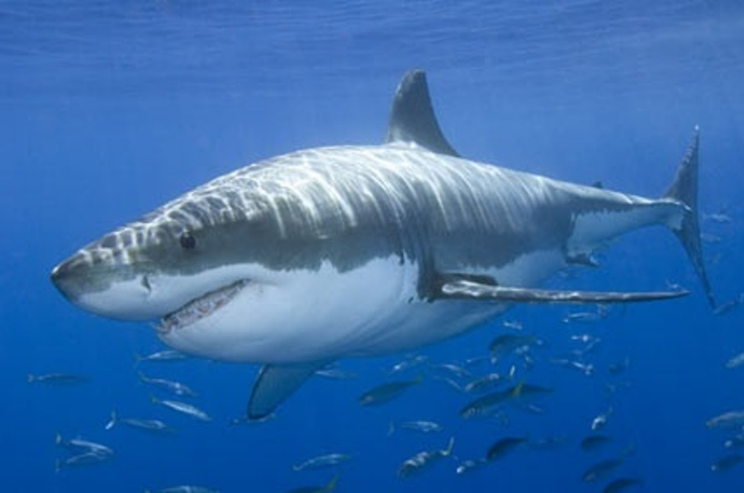
This is a Great White Shark.

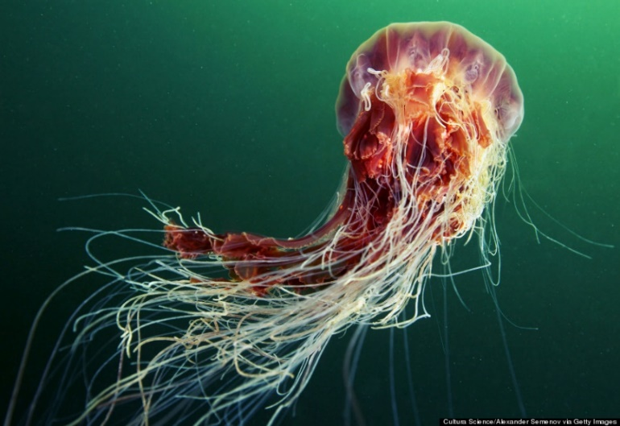
This is a Lion’s Mane Jellyfish.

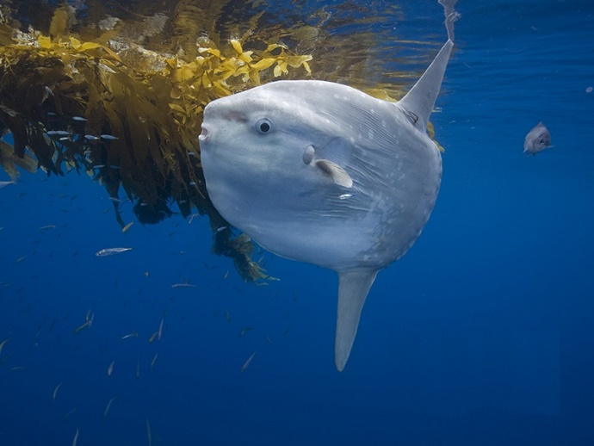

This is an Ocean Sunfish.

This is a Giant Clam.

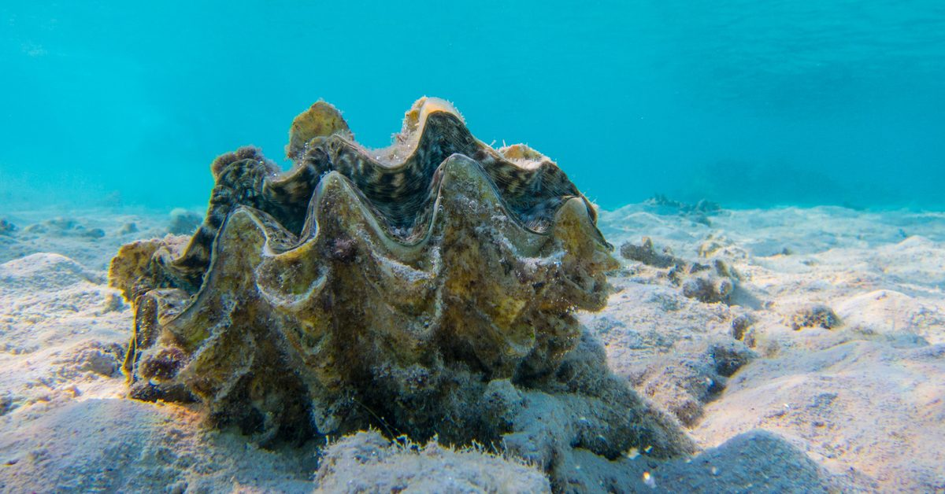

SEE THE ANSWERS BELOW:

-The Walrus is 3 metres and 80 centimetres (3.8m) long.
-The Giant Octopus is 9 metres and 80 centimetres (9.8m) long.
-The Blue Whale is around 33 metres long.
-The Leatherback turtle is around 2 metres and 10 centimetres (2.1m) long.
-The Great White Shark is around 7 metres long.
-The Lion’s Mane Jellyfish is around 36 metres and 60 centimetres (36.6m) long!
-The Ocean Sunfish is around 3 metres and 30 centimetres (3.3m) long.
-The Giant Clam is around 2 metres long.
Now you need to make a homemade metre stick. Have a look outside and see if you can find a branch that is around 1 metre long (if you don’t have a tape measure, then you can have a good guess). You could use a piece of rope or string instead if you can’t find a branch. Estimate 10cm intervals along the branch or piece of string and mark them with chalk or a pen (remember, there are 100cm in 1m).
Can you measure out the length of some of the creatures using your metre stick? You could try this outside.
Can you compare the creatures to another object? For example, the Giant Clam might be the same length as your sofa.
Can you convert the length of each creature into km or mm? Use the box below to help you.
Extra challenge task: can you calculate the total length of all of the creatures listed above?

10 mm = 1cm
100cm = 1m
1000m = 1km

mm to cm = ÷10 km to m = x1000
cm to m = ÷100 m to cm = x100
m to km = ÷1000 cm to mm = x10

