Key Learning Tasks

Team: Miss Bremner |  | Week: 12/06/20
Literacy:  Create a poster to persuade people to save the ocean and keep animas safe.  https://www.youtube.com/watch?v=xQ3E5BxKmBs | Numeracy:  https://www.bbc.co.uk/bitesize/clips/zmxqxnb  With an adult’s help measure out a 1 metre long stick.  How many metres do you think a great white shark is?  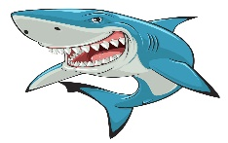  Ans=7ms | Topic  Wild bingo  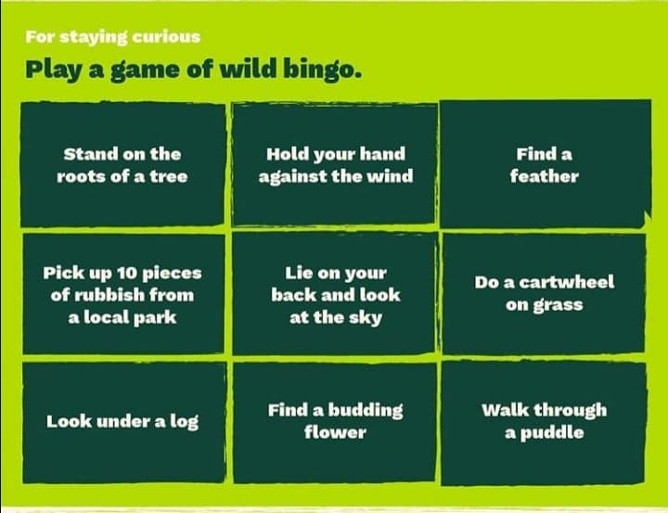 | PE:  T-Shirt Challenge. Place different t-shirts on the ground. Can you jump between them like a dinosaur?  If you miss a t-shirt then you should do 5 star jumps!
HWB  Pick your favourite snack to have. Can you draw a picture of you and your snack?  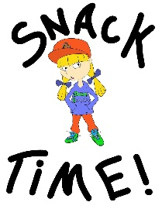 | Literacy:  Have a listen to the video of Goose on the Loose https://m.youtube.com/watch?v=NpYytwHl7YQ Can you think of other animals that migrate to different areas for summer? Have a listen to this mystery doug video to find out why animals go to warm places for winter. https://m.youtube.com/watch?v=ljrKsuXYwmU. Can you design a poster to share what you have learned about why animals migrate? Include two facts you have learned. | Numeracy:  Take you numeracy outside. You will need a jar of water, a paintbrush/stick and your wonderful numeracy brains.  Choose your challenge and write the answers in water on pavements or tarmac near your house.  1 star 2+1 3+1 2+3 2+2 1+1 3+3  2 star 3+4 5+4 5+6 5+5 6+6 4+4  3 star 10+2 11+4 6 +7 7+7 8+8 9+9 10+10 | French  https://www.youtube.com/watch?v=pHBxt2XajyU  Watch the video to find out how to pronounce the names of sea creatures in French.

