RAINBOW DAY
Team: Apple Hut Extra | Week: Friday 12-06-2020
Literacy  Positive Diary - Practising Positivity.  - Think back over the last week can you write/ draw something good that happened each day?  - It can be something you did or enjoyed, something big or something small.  - Try to think of something for every-day. | Numeracy  Symmetry Hunt  What you need: a piece of string  Begin with a hunt for symmetrical natural objects. Use your piece of string to ‘half’ the object to check if its symmetrical.  Create a list of symmetrical objects or photograph them.  If you have forgotten what symmetrical means have a look at BBC Bitesize - What Makes a Shape Symmetrical?  Extra challenge – create a symmetrical picture using sticks and stones… | STEM Challenge  Create a board game. This challenge requires you to be as inventive as you like. To start with think about what board games are your favourite.  Resources: paper, crayons/pencils, cardboard, counters (paperclips, buttons etc)  - Plan your board game.  - Make your board game.  - Test your board game.  - Once you’ve tested reflect on your board game.  Take a photo of you playing your game and share it with us! 😊
Art  Water painting.  Find a dry flat surface outside and create a water picture.  Use water to draw your favourite animals or movie characters.  Try different sizes of things to paint with for example, sticks, leaves or your fingers.  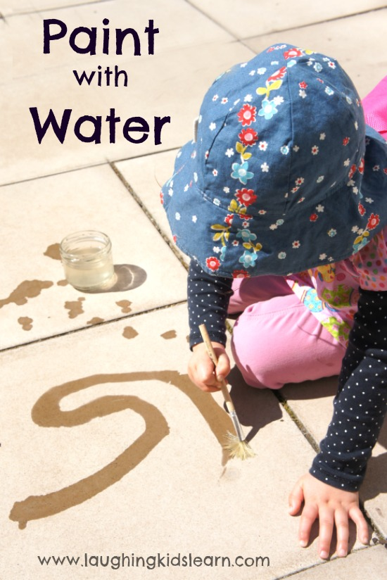 | Drama  Pretend you are the presenter of a television show. To an imaginary camera (or you could get someone in your house to be a camera person.) describe a safe outside space. Explain to your ‘viewers’ what the weather is like and pick two or three features to talk about in your report. These could be bright flowers or a specific tree you like. | Topic: Create and design your favourite sandwich.  Write instructions on how to make your favourite sandwich.  - What does it include and why is it your favourite?  - Are any of the fillings from the farm or locally produced?  Maybe you could make it for your lunch!

