A Leafy Tower of Hanoi
The Tower of Hanoi is a maths puzzle that is traditionally completed on rods with wooden discs. However, you can use different sized leaves instead.
The first job is to create a “base”. This can be drawn in forest litter with a stick. Alternatively, sticks, stones, cones or any other material to hand can be used to make the three squares.
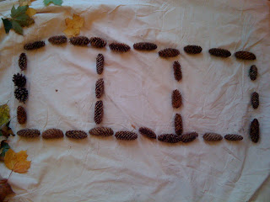
Next find three leaves of different sizes. In the example, they have used different colours as well so it is easier to see which leaf is smaller or bigger than the others. These go in the left hand square.
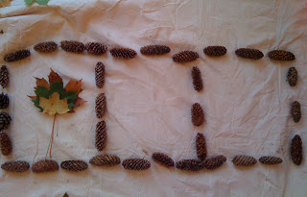
The aim of the puzzle is to move all of the leaves into another square so that they end up in the same order with the largest leaf on the bottom and the smallest leaf on top. There are some rules to follow.
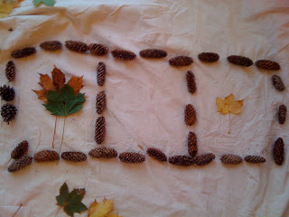
Firstly only one leaf may be moved at a time.
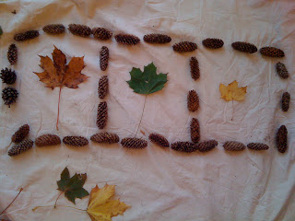
You may only move the top leaf on a pile. It must be moved to one of the other squares.
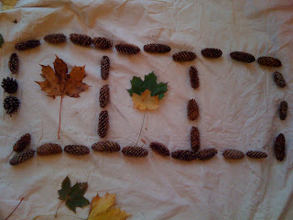
No leaf may be placed on top of a smaller leaf.
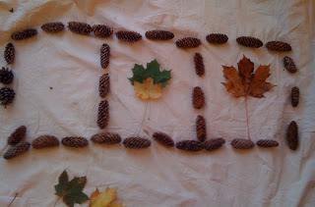
The more leaves in your pile, the more challenging the problem becomes. You could add some extra leaves if you manage to solve the puzzle with 3!
With three leaves, it takes seven moves to complete the puzzle. With four leaves, it takes fifteen moves. With five leaves it takes thirty-one moves. Can you work out the pattern?

Dara – An Outdoor African Maths Game

This game from Nigeria requires two players or teams.
It is played with stones or sticks on the ground.

Make the game board
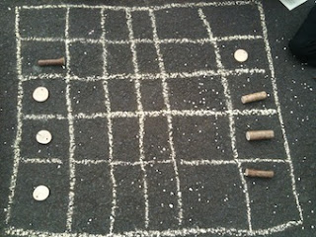
Using chalk (you could use sticks if you don’t have any or you could draw it on paper), make a 5×6 square as a game board.

Find some counters
You can play alone against an opponent, or as opposing teams. Each side needs 12 counters. In the photos, the class used wood cookies and noggins. Stones, shells or other gathered counters can be used from your garden. So find and gather your counters from materials lying around outside (ask an adult first). Make sure each side has recognisably different counters.
How to play
- If you are playing just one other person, take turns to place a counter anywhere on the game board until all counters have been put there. Whilst this is happening neither player can remove each other’s counters. Neither side can have more than three counters in a row at any one time. This is not allowed- see the example picture below:

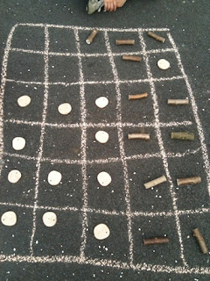

This is an example of an “illegal” game board as there are more than three counters in a row on both sides. It may take a while to get the hang of the game.

2. Take turns to move a counter into an adjacent empty square. The counters cannot be moved diagonally but can be moved up, down or sideways. The aim is to make three counters sit in a row (but not a diagonal one).
3. When a player manages to make three counters in a row, they can remove one of their opponent’s counters. A player can only remove one counter from their opponent in any one go, even if more than one row of three counters is created in a move.
4. The game is over when a player is unable to make three in a row with his or her counters. Their opponent wins when this happens.
Here is a video if you would like to see an indoor version of the game in action!
https://www.youtube.com/watch?v=_O3_K7CCYFA

Nature Mastermind

You will need a partner for this game.
You might have played the game Mastermind in school. It’s a form of code cracking where you have to work out the hidden line of coloured pegs.
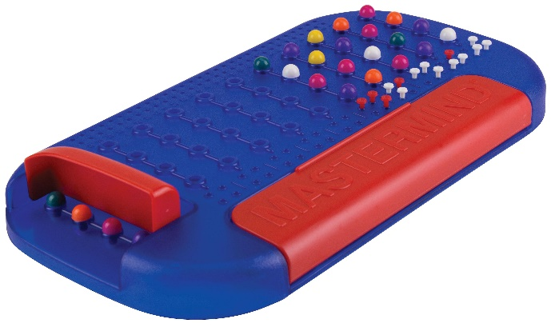
Like many strategy games, it can be easily adapted and played outside with gathered objects.

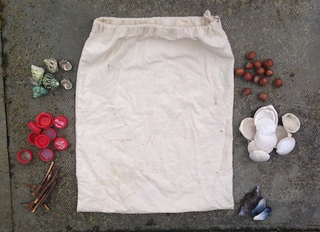
First you need six piles of natural or household objects. A bag that you cannot see through or a piece of material or clothing is needed too. Gather around 8 of each object. Have a piece of paper to hand along with 3 different colours of pen or pencil (red, orange and green work well). Ask an adult before you collect items.

Next, put 4 objects in a row at the top of, and inside the bag. In the example, they have used a mussel shell, twig, bottle top and hazelnut.
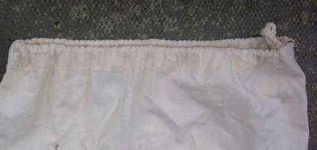
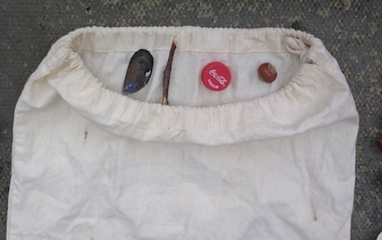
After that, cover up the line of objects. It is important that your partner does not see this line. It’s their job to work it out through strategy and logic. Your partner can now have their first go at guessing the objects and the order that they are in.
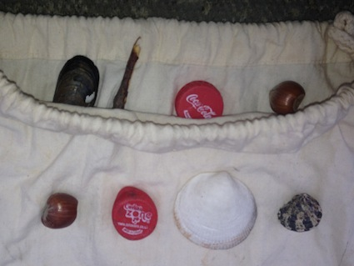
Here is an example of a first guess (the bag has been opened up so you can see the difference). Only 2 of the objects are correct but they are in the wrong place.

Now you need your paper and 3x colours of pens or pencils. You need to record your partners result so that they can use this information when making their second guess. Use one colour to indicate the correct object in the right place (green for example), use a second colour to indicate a correct object but in the wrong place (orange for example) and use the third colour to indicate if the object is not in the code at all (red for example). Record it on the paper like this:

Your partner can now guess again. In the 2nd row, there are 3 objects which are in the line-up but none are in the right column.
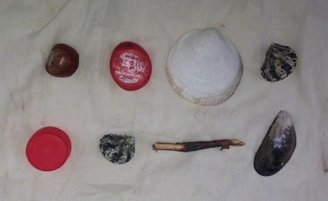

On the third attempt, a similar situation has happened. 3 out of 4 objects are correct but all are in the wrong columns.
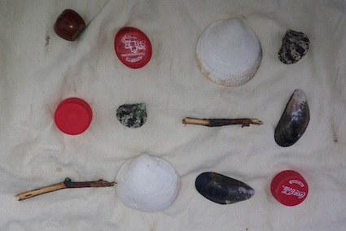

With the 4th attempt, the person has got a lot closer to working out the line-up. All of the objects are correct and the red bottle top is in the correct place.
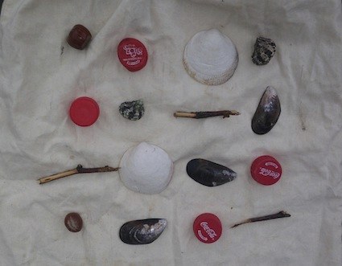

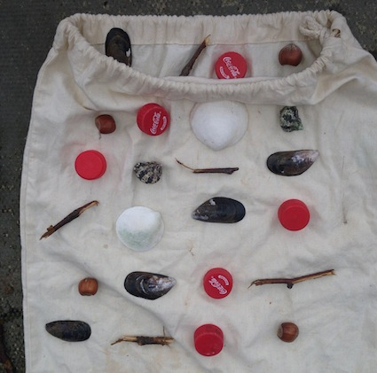
The puzzle has been completed by the 5th row! The line-up of objects matches the hidden line-up! Hooray!

