Key Learning Tasks
Team: Miss Bremner |  | Week:
Literacy:  Design your own dinosaur – Draw a picture of what you think a dinosaur would look like. Label your dinosaur using descriptive words.  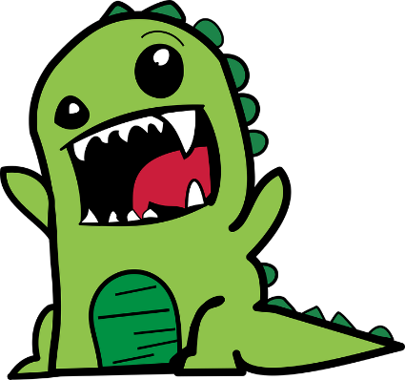 | Numeracy:  Doubles to ten  https://www.youtube.com/watch?v=8jOzhiACB68  Play the top marks game  https://www.topmarks.co.uk/maths-games/hit-the-button | Topic  World environmental day 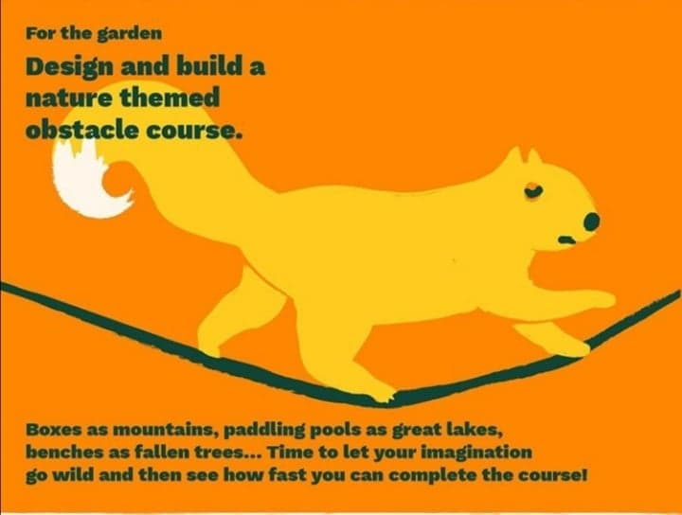 | RME:  We have done lots of learning about Buddhism. Can you draw a picture of what you remember about Buddhism?  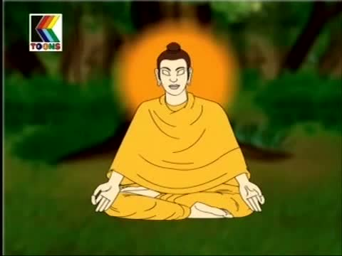
HWB  We are learning about Table Manners. These are rules that we have for eating politely at the table. Watch the video and think about table manners in your house. https://www.youtube.com/watch?v=mgZeziVUsZ0 | Literacy:  Create a dinosaur comic strip.  Go on an adventure with your dinosaur by drawing a series of pictures.  **Extra challenge**  Caption the pictures to state what is happening in each picture | Numeracy:  We are looking at probability and the likeliness of something happening watch this video to find out more  https://www.youtube.com/watch?v=TedbpetdzBE | French  Learn how to talk about your family  By watching this video https://www.youtube.com/watch?v=L5-3kpXaEi4​  ​

