RAINBOW DAY
Team: AppleHut Extra |  | Week: Thursday 04-06-2020
Literacy:  Time capsule  What you need: bottle or small plastic container, paper, small items of memorabilia (photographs, favourite magazine cuttings, 2020 coin/stamp, drawings etc.)  What to do:  Collect pieces of memorabilia (see list above). Write a short letter about life in 2020 to remind your future self.  Place everything safely in the container  Secure the container with tape or string  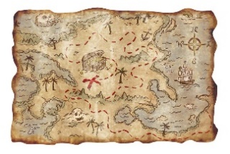  Dig a hole in your garden (or hide it in the attic)  Wait 10 years..can you do it??  Open your time capsule in a decade and be amazed at what is inside!  TIP: Create a map of your garden to remind yourself where it has been buried! | Eco Art!!  Rock Art  What you need: rocks/stones and paint  What to do: Choose how you want to decorate your rocks. Could you make them look like something else?  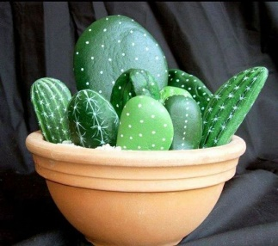  Paint your rocks and post some pictures to show the team! | Science/topic  Welly boot planters  What you need: An old welly boot (or any old boot/shoe) Soil/compost, seeds or plants that can be replanted.  - What to do: decorate your boot, add bright colours or some glitter  - Fill your boot with soil  - Plant your seeds/plants  - Keep a weather diary and watch your seeds grow.  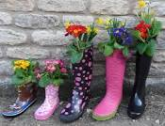  Remember to water them and to ask an adult’s permission before you use a welly boot.
HEALTH & WELLBEING  Good morning yoga  Find a spot outside and practice your morning yoga. Can you strike poses to mimic things you might find in nature? Could you be a tree or a bird? Listen to some relaxing music as you practice.  If you would like some guided yoga, follow along with Adriene…  Adriene's Yoga | Hunting for gold!  This Photo by Unknown Author is licensed under CC BY-SA  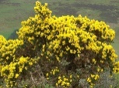  Go out on a search for all things golden in nature. You could take a photo of all the golden objects you can find, or you could note them down. | Numeracy:  Become an insect architect and design a bug hotel  Create a multi-story hotel that is full of all sorts of natural materials, providing hidey-holes for creatures galore.  Follow the link for a step by step guide.  RSPB Bug Hotel Instructions  Measure the height of your brilliant bug hotel!

