The following pages contain a variety of probability experiments for you to try. You can choose the tasks that you find most interesting.

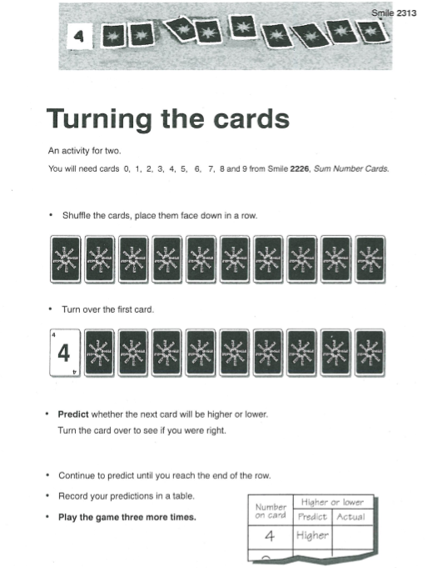

**You will need to make some cards with the numbers 0, 1, 2 3, 4, 5, 6, 7, 8 and 9 on them.**

**TURNING THE CARDS CONTINUED**

**You will need a pack of playing cards for this activity.**

**You don’t have to print and cut the cards out. You could just match the letters on the spinner cards with the numbers on the probability lines.**

**LUCKY DIP**

You will need the cards with different pictures in that are shown below. You don’t have to print and cut them out, you can make them yourself instead if it is easier.

**LUCKY DIP SCORE SHEET**

**You can draw a rough version of this instead of printing it out.**

**Lucky Dip Questions**