RAINBOW DAY
Team: AppleHut Extra |  | Week: Thursday 28-05-2020
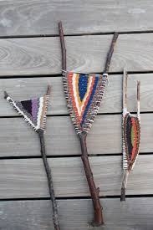  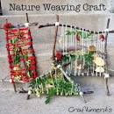  ART  Stick Frame  Weaving  When you are outdoors you might like to make a weaving frame from sticks. You could weave using natural objects or you could use scraps of materials or wool that you have at home.  Don’t forget to ask before you use materials from home, always respect nature & work safely!  Here are some ideas to get you started…  Mother- Natured Large Weaving Video  Create a Y Stick Loom  More Nature Weaving Ideas | Eco Construction!!  Build a Mini-Den!  Use natural objects from your garden or collected during your daily walk to build a mini-den for a toy, animal or even your imaginary letter-writing creature!?  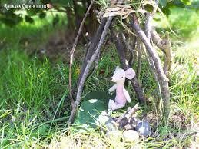  https://rhubarbandwren.co.uk/mini-den  Explore which shapes make the strongest dens and share your findings on the recording sheet.  Strongest Shapes Video  Mini Den Engineering Recording Sheet | SCIENCE  Water Cycle in a Bag  SMO - Water Cycle in a Bag  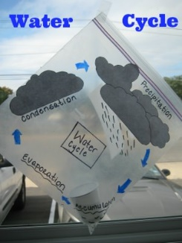  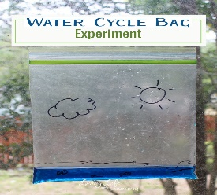  You can make your water cycle model as simple or as detailed as you wish.  Then you could try singing this song….  Water Cycle Song with Actions
HEALTH & WELLBEING  YOGA  Teams Bremner & Keenan try…  Garden Yoga  Team Muir try this Yoga Sequence called ‘Sun Salutation’….  Sun Salutation - Easy Guide  You could put on some lovely. Relaxing music to perform the sequence to! | GENIUS HOUR!  This Photo by Unknown Author is licensed under CC BY-SA  Mrs James's Introduction to Genius Hour  OR  Genius Hour - Part 2  On this Double Rainbow Week, you can either get started with your Genius Hour or continue to work on your project over the 2 days!  Happy Creating….. | Make a Nature Journal  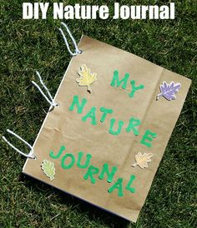  Create your own personal Nature Journal to record the minibeasts that you found in your garden!  Use a notebook you already have or paper to create one from scratch – the choice is yours! Then you can keep adding to your records about the ‘nature treasures’ that you find on Rainbow Days!  - Draw a picture/take a photo  - Note where you found it  - Any interesting observations/notes  - Add ‘pockets’ to keep ‘Treasures’ in  Here is a recording sheet in case you need it….  Minibeast Nature Journal Sheet

