RAINBOW DAY
Team: AppleHut Extra |  | Week: Wednesday 27-05-2020
Literacy:  Mud creatures  What you need: Wet mud, natural objects for features (twigs, flowers, grass)  What to do: Use the sticky mud to create the body of your creature  Use natural objects to give the creature features such as legs, wings, teeth, tentacles, eyes, and claws etc.  Write a character description  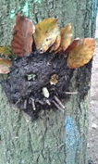 | 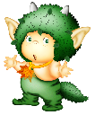  Eco Art!!  Upcycle your rubbish  HEALTH & SAFETY!  As with any Science experiment or craft project remember to work safely and ask for adult help for cutting!!  Think of all the different creations you could make.  A pencil holder out of toilet roll tubes  A robot out of cardboard boxes  A piggy bank out of a bottle  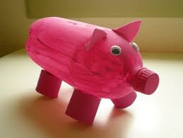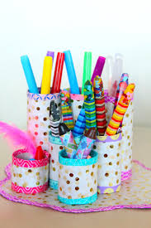 | SCIENCE  Bug hunt-Pitfall trap  You will need: a yoghurt pot, banana or any sweet sticky food, scissors  What to do: Make small holes in the bottom of the yoghurt pot, Choose a spot in your garden with lots of cover (at the bottom of a tree or bush is perfect), Dig a hole the same size as your pot, Put your pot in the hole making sure the rim is level with the soil, add your banana to the pot, Leave the pot for a few hours, return with your minibeast identification and see what you have trapped. Remember and let all bugs free at the end of the experiment.  Check which mini beasts you have by looking at https://www.rbkc.gov.uk/PDF/Minbeasts%20pack.pdf
HEALTH & WELLBEING  Obstacle course  Can you design an obstacle course in your garden? You could challenge a family member to complete it or ask a family member to time you. | GENIUS HOUR!  This Photo by Unknown Author is licensed under CC BY-SA  Last week you dedicated an hour to researching something that you are passionate about. See if you can take your challenge further today. | Numeracy:  Mud Kitchens  Go into your gardens and cook up a storm. Could you create a fairy-tale picnic made completely of things found in your garden?  Weigh out your ingredients using standard(g) or nonstandard measurements (cups, handful). Then write a recipe for your creations

