RAINBOW DAY
Team: AppleHut Extra |  | Week: Thursday 14-05-2020
Literacy:  Make a miniature envelope and letter from an imaginary garden creature. Perhaps from your very own Waldgeist?  Teams Bremner & Keenan – make your envelope and write a short letter from your character telling us who they are.  Team Muir – See how much you can fit on your tiny letter – you’ll need to be neat! Introduce your character, what do they look like, where do they live and what do they get up to in your garden/home/shed…..  Make a 'Leaf' Envelope  Mini envelope and letter templates to PRINT | 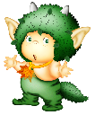  Eco Art!!  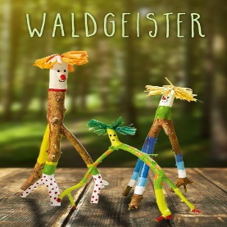  Find an interesting stick in your garden or during your daily walk. Strip off any bark, clean the stick and decorate it using any materials you have at home to create a ‘Waldgeist’ Stick Character (German for Wood Spirit).  Can’t wait to meet them!! | SCIENCE/MUSIC  Make a Nature Wind Chime  Can you use sticks that you find in the garden or on your daily walk to create a windchime? You could even paint it like a Rainbow! There are lots of ideas if you search online…  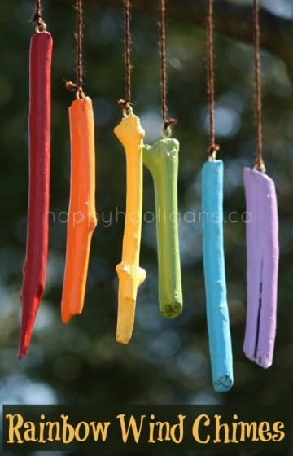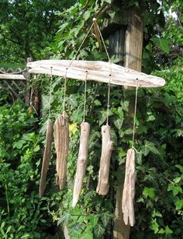  Investigate what happens to the sound that the sticks make if they are of different thickness and length – What do you notice?  Use the recording sheet to let us know!  HEALTH & SAFETY!  As with any Science experiment or craft project remember to work safely and ask for adult help for cutting!!
HEALTH & WELLBEING  YOGA  Teams Bremner & Keenan try…  Cosmic Yoga - Bug Yoga!  You could take your tablet outside or have a go indoors and then practice your poses again in the garden.  Team Muir try…  Garden Yoga  Enjoy the peace and tranquility…. | INTRODUCING….  This Photo by Unknown Author is licensed under CC BY-SA  GENIUS HOUR!  Mrs James's Introduction to Genius Hour  Good luck with identifying your passion! You will find more instructions and planning sheets on Teams and the school website. | 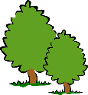  Numeracy:  Measure a Tree!!  Try this investigation during your daily walk if you don’t have a tree to measure in your garden. Or you could measure something else like the shed or your house!!  Tree Measuring Tips Video  You will find more instructions and sheets in Teams or on the school website.  Remember to take and share photos and videos of your measuring activities.

