Up-Level the Sentences

The bath went through the water. It was a sunny day. The girl watched a turtle.
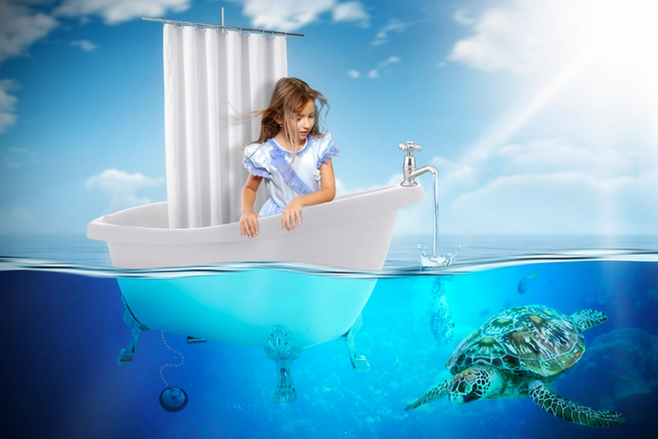
Make the simple sentences above more exciting by adding interesting vocabulary, connectives, openers and punctuation. Try and use your best handwriting. To challenge yourself further, you could make the sentences into an exciting story.

