Fraction Strips are shown below to help you compare the fractions that are given. The fraction strip on the top represents the fraction on the left. The fraction strip on the bottom represents the fraction on the right of each box.
- Colour in each fraction strip to represent the fraction given. The second half of the sheet has already shaded the fraction strips so you have to write down the fraction that they represent.
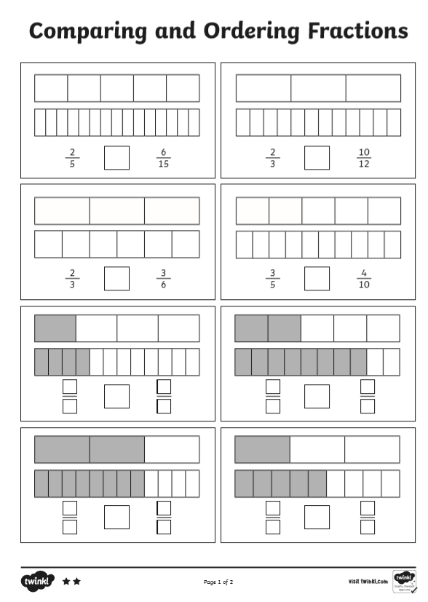
- Use the < , > or = signs to compare the fractions. See the bottom of the assignment for a reminder of how to use the signs.
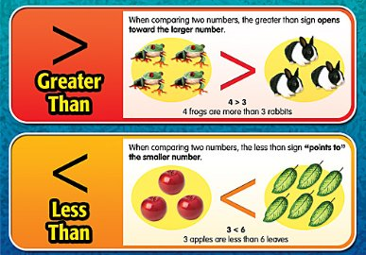
Below are some fractions for you to put in order from smallest to largest. Draw some fraction strips to help you. Here are some instructions to help you do this:
- Find the largest denominator in the list. For example, for question a, the largest denominator is 12.
- Draw a fraction strip that has been divided into 12 equal parts.
- We have three fractions to order, so draw another two fraction strips underneath. We want to make the denominator the same so divide them into 12 pieces too.
- Next, I have coloured in the fraction stated. Now I have a clear picture so I can put them in order.
$$\frac{1}{2}$$
$$\frac{8}{12}$$
$$\frac{1}{3}$$
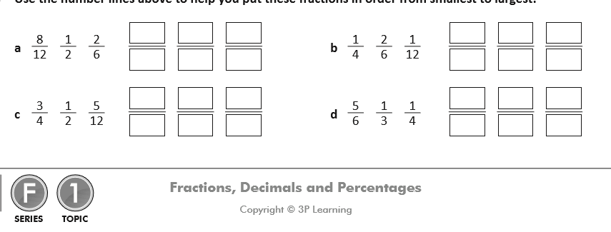
$$\frac{1}{3}$$

