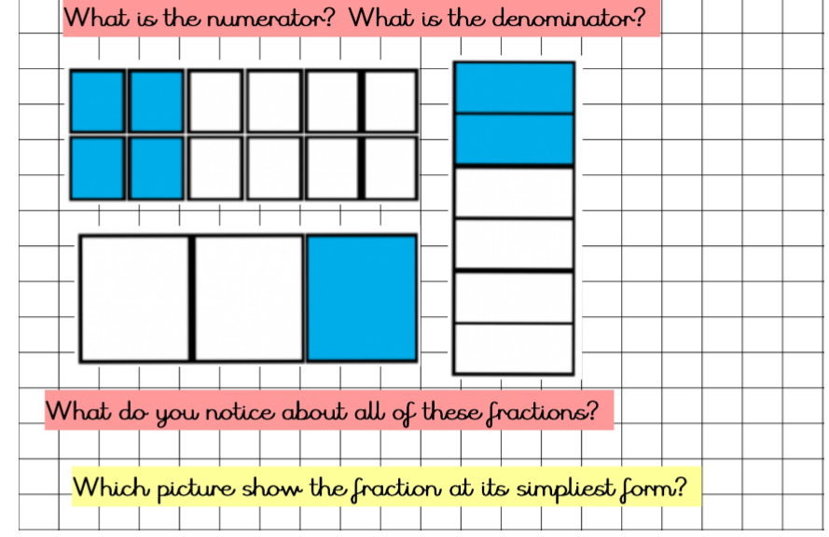

1.

(Write down the meaning of each word.)

2.

3.

(Circle the correct diagram or draw it out.)

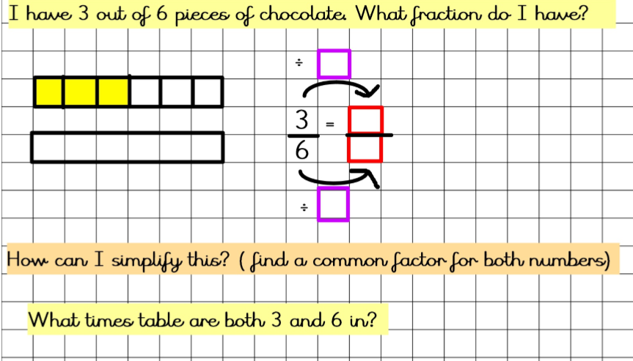

4.

3

3

We know the answer to this is 3. Fill in the red boxes to show the simplified fraction. Show this fraction by shading in the blank rectangle.

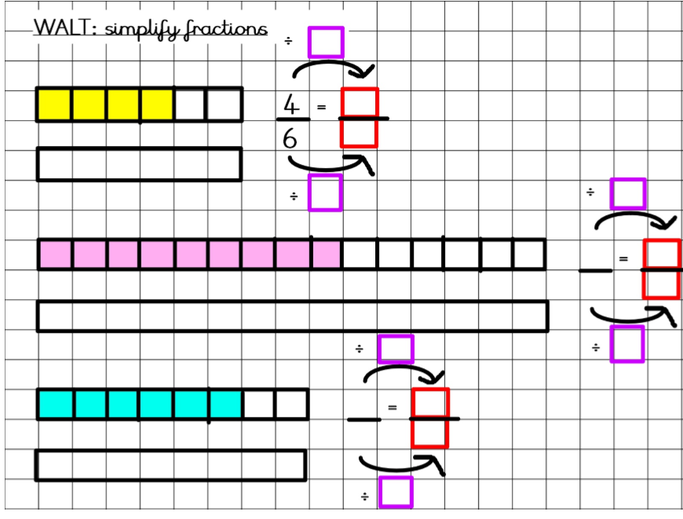

Using the highest common factor in the purple boxes, simplify the fractions given. Show the simplified fractions by shading in the blank rectangles.

5.

2

2

9

3

3

6

Can you identify the highest common factor? Think about the times table that you can find both the numerator and the denominator in.

8

15

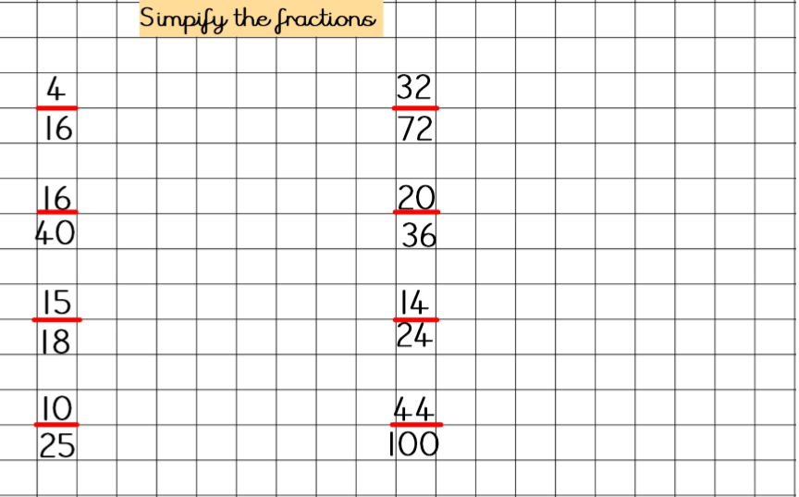

Use the same method that is shown above. Think about what times table both the numerator and the denominator can both be found in.

6.

8

155