Dad and I made a Defender stove the 16-inch model
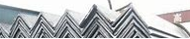
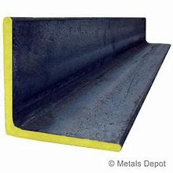
floor of the stove is made of angle iron
The wall of the stove is made of iron Defender wheels
The legs of the stove are made of angle iron
As soon as a fire is lit, rising hot air and the absence of oxygen created by the combustion process creates a vacuum at the bottom of the Defender wheel’s burn chamber. This vacuum draws oxygen in through the Defender wheel’s bottom exterior vent holes, immediately fueling the fire at its base.
The smoke and warm oxygen help to further fuel the flame, resulting in secondary combustion, a more picturesque flame, and a hotter fire that burns off the smoke.
As mentioned above, this happens to an extent regardless of the size of the fire in your Defender wheel. This is how I got my picturesque, Instagram-worthy Photos
