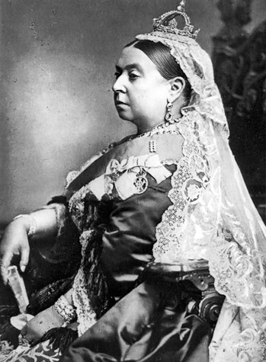
ANNANDALE & ESKDALE PRIMARY SCHOOLS CURLING FESTIVAL 2020
The curling festival will be held on Wednesday 11 March 2020 at Lockerbie Ice Rink. In order for us to enter a team from each school, could you please indicate if your child would like to participate. Reply slips should be returned on Monday 20 January 2020. Further details will follow nearer the time.

OUR ECO SCHOOL
Rag Bag Collection – 31 January
Thank you so much for continually making tremendous efforts to feed our recycling clothing bin! Your unwanted clothing always generates money for our school funds and the Rag Bag donation is most welcome. Please spread the word to your family and friends. Extra bags are available from the school office.

THE LION KING
Wednesday 26 February
Following a very successful bid to Hutton Community Fellowship which is funded by Scottish Power Renewables Ewe Hill Windfarm, I am delighted to inform you we have secured funding which will support us all to go and see The Lion King at The Playhouse, Edinburgh. We are so excited!
A huge thanks to the Parent Council
for applying for the grant.
More information to follow.

VICTORIAN EXCURSION
New Lanark Victorian Adventure
Thursday 30 January
Thanks to the aforementioned Windfarm funding and the shared fundraising monies we have planned an excursion to New Lanark as part of our project on Victorians. Please note this is part of our school curriculum.
On this occasion a small donation is requested towards the cost, please contact Mrs Fraser if this causes you any difficulty.
School packed lunches are available on this day – if you would like to take up the offer please complete the order form.
Can you please complete the enclosed permission forms and return them by Monday 20 January. Thank you.

JUNIOR GALA APPLICATIONS
Applegarth Primary P1 ONLY
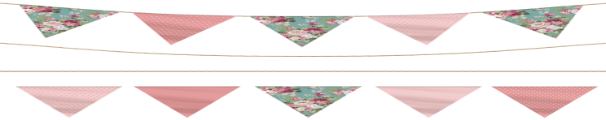
We have recently received a request to send out the application form for Lockerbie Gala Junior Principles – please find enclosed. If you would like your child to be considered as the representative at the Gala and Riding of the Marches and are able to commit please complete the application form and return it to the school office by Monday 20 January.

PUPIL DROP OFF
A gentle reminder. Pupils should not be dropped off at school before 8.30am. Please also note the playground is unsupervised before 9am.

RETURNS
As you are aware, to best utilise staff to meet the needs of the partnership the school offices are not always manned. The request for letter bags and home school link bags to be returned on a Monday is to ensure we can collate all the returns efficiently and effectively in both schools. I would ask that both ‘bags’ are returned every Monday.
Many thanks for your continued support.
Mrs Fraser

AFTERSCHOOL CLUB
Active Schools Dancing P4-7
We are delighted to be able to offer our P4-7 pupils at Applegarth and Hutton the opportunity to participate in a dance afterschool club starting on Thursday 30 January, 3.30 – 4.30pm. The final session will be on 12 March. You will find enclosed a letter giving further details, the permission slip and booking form which should be returned Monday 20 January. It is the responsibility of the parent/carer to transport their child.

ENCLOSURES:
- Term 3 Parental Overviews (in plastic wallet at back of Home School Link Book)
- Active Schools letter and registration form
- Wee Dee Gee lunch order for New Lanark
- Rag Bag Collection bag
- Valentine Coffee Morning Poster

ANNANDALE & ESKDALE
P5 - 7 PRIMARY SCHOOLS CURLING FESTIVAL 2020

My child ………………………………………………………
wishes to take part in the curling festival

Signed ………………………………………………Parent

Please print name ……………………………………….

Return on Monday 20 January 2020

PARTNERSHIP VALENTINE COFFEE MORNING
Saturday 8 February 10am-12noon
Lockerbie Town Hall
Please indicate on the list below where you would like to help and give an idea of which items you would be able to provide. Please return on Monday 20 January. Thank you.
NAME: ………………………………………………………………… PLEASE PRINT NAME ……………………………………………………
 | I can help with the following: Please | I can provide items for the following stalls:
Setting Up
Door
Kitchen (teas & coffees)
Adopt a Teddy
Raffle
Cake & Candy
Tombola
Odd Sock Washing Line
Wine & Water
Fill a Jar Stall
Clearing Up
Can help where required
Donations of the following items are required
Wine
Home Baking for the Teas and Coffees and Cake and Candy stall
Odd socks for the Odd Sock Washing Line
Cuddly toys for Adopt a Teddy
Tombola prizes
Raffle prizes
Sweets
Jam Jars filled with goodies
There will be a sub meeting to finalise arrangements at Applegarth Primary on Friday 31 January @ 3.15pm
Anyone wishing to help organise the items and transport to the Town Hall please come to Applegarth School on Friday 7 February @ 2.15pm. The coffee morning is an essential fundraising event for the partnership and all support and donations would be very welcome.
There is a Valentine poster enclosed to help promote the event. Please display this in any local organisation or shop to help advertise the event.

