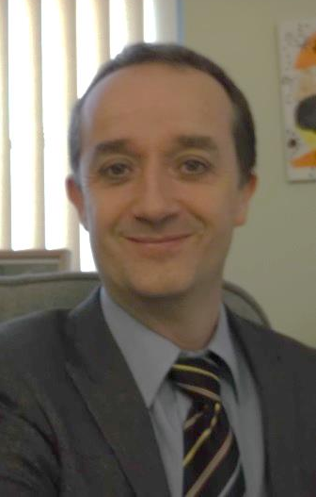
St. Andrew’s Primary School Curriculum Overview.

Welcome to our curriculum overview for Science.
The idea behind this document is to share information about your child’s learning in Science. We have tried to make it as accessible as possible. With that in mind it is still important to explain some of the terms used.

Es &Os.
This is shorthand for experiences and outcomes. These are the key elements provided by the national guidelines. Schools in Scotland are expected to use these.

Early Level, First level, second Level.
These provide guidance in general terms about when most children should achieve a level by.
Level | Stage
Early | The final two years of early learning and childcare before a child goes to school and P1, or  later for some.
First | To the end of P4, but earlier or later for some.
Second | To the end of P7, but earlier or later for some.
SALS- Significant Aspects of Learning
These are again provided by the national government. They are key milestones in the assessment process for your child. Not all experiences and outcomes need to be covered with your child to say that they have achieved a level but all Significant Aspects of Learning are expected to be.

Learner Statements
These are key elements of the SALs that learners use to reflect, judge progress and set targets.

