Sheuchan Nursery Newsletter Sept/Oct 2022
HRM Queen Elizabeth II
It was with great sadness that we learned of the death of Her Majesty the Queen. Sheuchan School and Nursery community would like to express our deepest sympathies to His Majesty King Charles III and his family. As a mark of respect, it is agreed that schools and nurseries will close on the day of the funeral, Monday, 19th September 2022.
Peep – Family Learning
Peep sessions are a fun way in which parents can be supported to learn together with their children. We are delighted to be able to re start these sessions which will take place within our Sheuchan School Family Room. I am sure you will all have spoken to Miss McKie who is fully trained in the delivery of Peep, however if you haven’t had a chance yet and you would like to join her first session on Friday the 23rd of September please let us know.
Stay & Play
We would like to invite our families into our term 1 Stay & Play session. This will be an opportunity to spend some time with the children experiencing all their favorite places to play and explore in Nursery. Stay and Play forms will be displayed within the Nursery foyer, please pop your child’s name against the session that suits you best from the following:
Tuesday 11th October 1.30pm-2.30pm
Wednesday 12th October 10am-11am
We will limit numbers each session to ensure there is no overcrowding indoors. During your Stay & Play session we would like to welcome you all to have a look over your child’s Personal Learning Journey to view all the fantastic achievements they have made so far this year.
Play dough bags
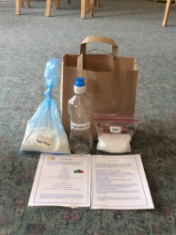
We hope you have enjoyed our first Family Bag of the year which is a nice way for you to engage in your child’s learning whilst having fun at home. We would like to thank all who sent photos and comments and would encourage all parents to respond to our short feedback survey which will be sent out soon. This will help us gage the success of the bags and gather some ideas to inform planning for our next bag. Please look out for our questionnaire coming soon around our bags as we would love your input in what you would like to see in them throughout the year.
MacMillan Coffee Morning – 30th September
Prior to COVID Sheuchan School always hosted a very successful coffee morning to raise funds for MacMillan Cancer. We intend to hold a coffee morning the morning of Friday the 30th of September in the main school hall. Donations of home baking for this event would be very much appreciated.
Harvest Thanksgiving – 7th October
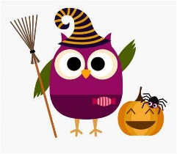
Our Harvest Thanksgiving will take place on Friday 7th October. Further details will be shared nearer the time.
Halloween
We are going to have a Halloween day on Monday 31st of October, our first day back following the October break. This will take place throughout the nursery day. The children are welcome to come to nursery in fancy dress costumes if they desire. Please label all clothing. We are sure that the staff will be dressed up too!
Holiday dates
Just a reminder that the October holidays run from Monday 17th to Friday 28th October. School will re-open on Monday 31th October. May we take this opportunity to wish you all a lovely holiday.
Nursey Contact
Just a quick reminder, if you wish to speak to your Keyworker or Miss Douglas please request a phone call whilst dropping off or collecting your child. We will be happy to arrange a suitable time for a chat. Could we just remind parents the Nursery WhatsApp should not be used for reporting absence, please do so via email or by phoning the School Office.

The Nursery Team

