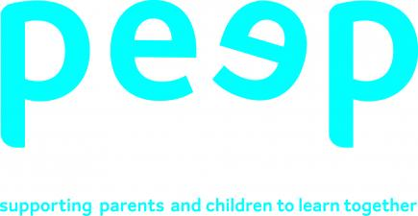
Peep – People Learning Together Programme.
Miss McKie has recently been involved in a new training programme designed to improve children’s life chances, by making the most of everyday learning opportunities – listening, talking, playing, singing and sharing books and stories together through parental involvement.

She is pleased to announce our Sheuchan Nursery PEEP sessions will commence on Wednesday 22nd of January at 10am. This will be a great opportunity for parent’s to come in to Nursery have a cuppa and a blether with other parent’s, spend time with their children and learn all that PEEP has to offer. Siblings welcome.
Should you have any questions please speak to Miss McKie who would love to know you are able to attend.
