Questions for the Arctic Experts at the British Museum
Joe: Caribou and rein deer are the same species but rein deer have been domesticated. Can you tell me about more differences between them?
Joe: Do you think the Inuit artefacts belong to the museum or the Inuit committees?
Sam and Sevi: What are the people eating in the picture?
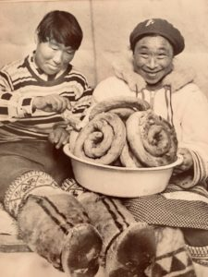

Sam and Sevi: What do the Inuits think of as lucky and why?
Rhona: What happens if they run out of food?
Jackson: How cold does it get?
Caspian: Have any other civilisations tried to conquer the Arctic but failed?
Tanith: Are there butterflies in the Arctic Circle?
Charlie: Are puffins eaten and what do they taste like?
Daniel and Abigail:
- How do polar bears walk on the ice and not break it?
2) Have the experts at the museum been to the Arctic?
3) Did they build an igloo and stayed in it?

