Polar Bear Project IDL week beginning 08.02.21.
Second Level

Activity 1 – Research in the Arctic
Science - Discovering the Arctic
The website above tells you about research that is happening in the Arctic right now. Read the first page, then explore the website to find out about the different research happening in different parts of the Arctic.
Task – Answer these questions. You can write the answers down in sentences or video the answers, as if you are a journalist reporting for a news programme.
- Which countries are doing research in the Arctic?
- Find four words from the website that are new to you and find the meaning of them. Write the words and meanings down.
- Give two examples of research that is being done in the Arctic.
- Can you find any research being done in the Arctic that impacts on Scotland?
- Can you think of any research that you would like to do in Holywood?

Activity 2 – Current Affairs in the Arctic
Current affairs means what is in the news at the minute. The most recent news about the Arctic is that just before Donald Trump left his job as the American president he allowed oil companies to rent land in parts of the Arctic that are in conservation areas. The new president will have to decide whether the oil companies are actually allowed to drill for oil in these places.
Drilling for oil could be a good thing for the Arctic people because if oil companies come to drill they will bring workers who will pay for somewhere to stay and for food, so it would bring some money to the Arctic. The people who are wanting to drill say that the people of the Arctic can rely less on the animals who live there, because transport is so much better these days that they don’t have to rely on traditional methods of hunting for food, they can buy it from the boats and planes that bring supplies.
Drilling for oil could be a bad thing for the Arctic because the animals who live in the conservation area may be displaced (have to find new homes) and because the ice is melting there is less space for them as it is. The people of the Arctic are respectful of nature because that is traditionally where they get their food and materials for tools and clothing for survival.

If you listen carefully to the children in this video, they give some alternative ideas to oil as a fuel.
Climate change: Arctic Circle teens call for help to save their homes - BBC News

Task – make a decision - Do you think drilling for oil should be allowed or not? Once you have made up your mind, write the content of an email as if it were to go to President Biden to persuade him what you think is the right course of action AND WHY you think this. If you would like to research the subject more, go for it!

Activity 3 – Arctic Art
Many artists are inspired by the Arctic scenery and nature. Here are examples of two artists who have painted the Arctic using different styles.
Ted Harrison often included people, animals and houses in his pictures. He used warm colours. The sky and land were painted in blocks, without much detail.

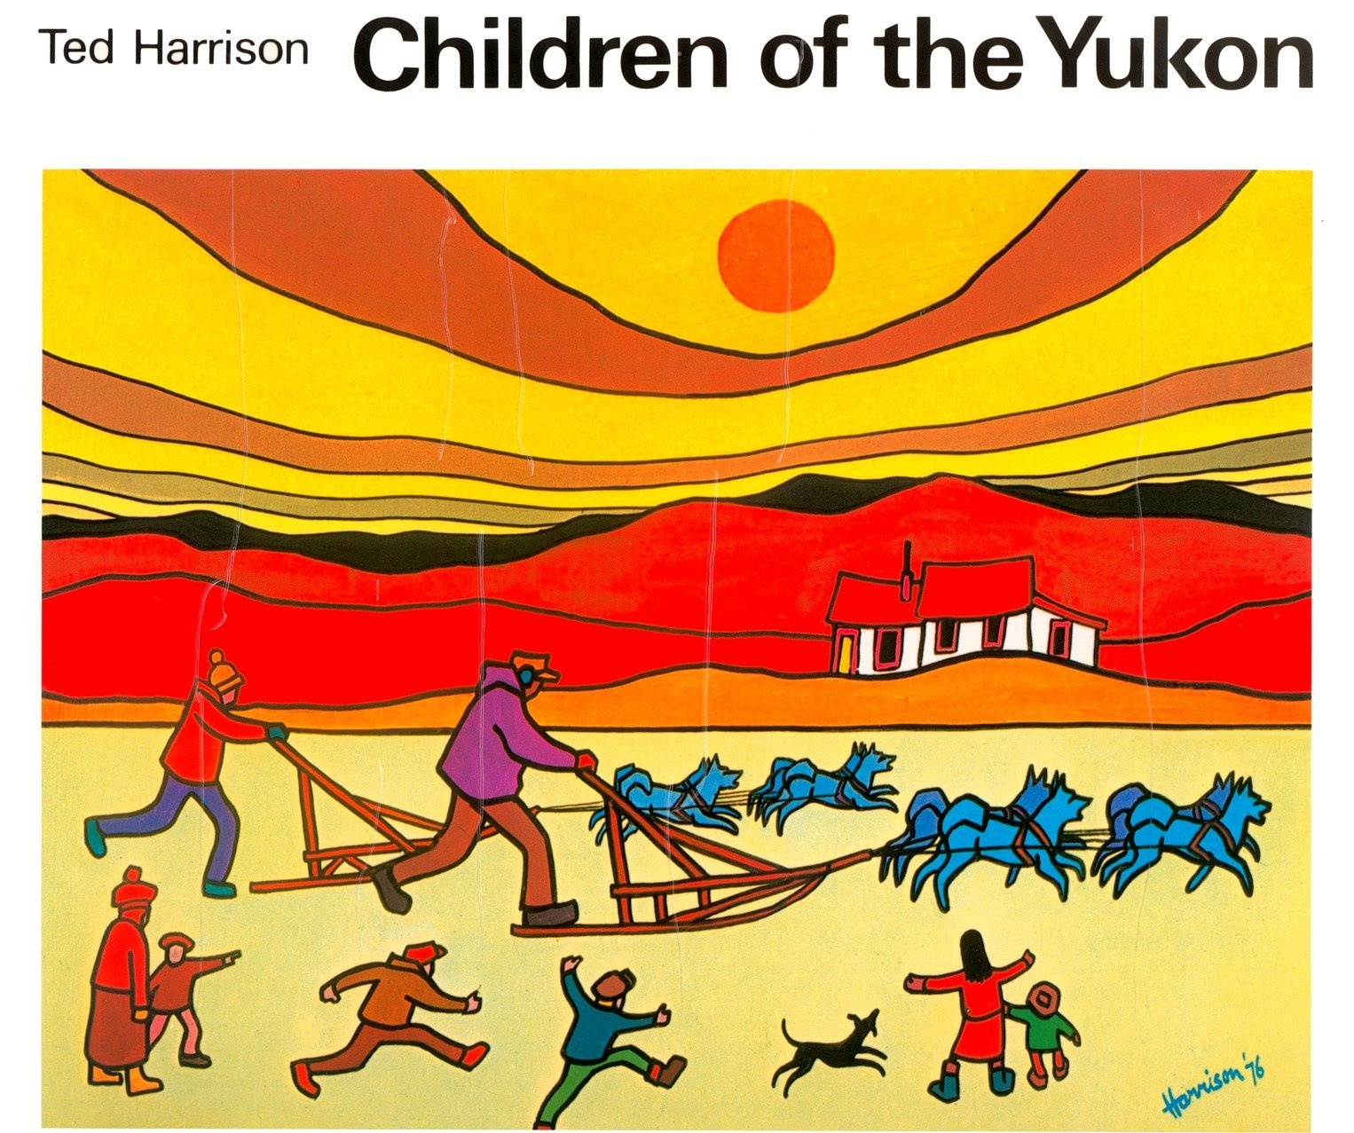

David McEown uses mainly cool colours when he paints. He sometimes paints the animals of the Arctic, such as polar bears, but mainly just the landscape, no people or buildings. Whereas Ted Harrison’s pictures are quite flat, David McKeown puts a lot of detail in the foreground and less detail in the background to show depth.

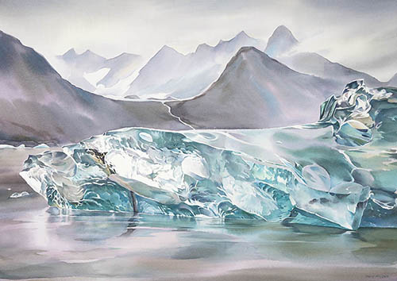
Task – Make 2 pictures, one in the style of each artist. They should be very different. Consider whether you will use warm or cool colours for each one, and whether you will include animals, people and buildings or just landscapes. Don’t worry if you don’t have paints at home, crayons, felt tips or anything that you have will be fine.

Activity 4 – Frankenstein and the Arctic
During this topic we have looked at lots of factual texts. Lots of authors have used the Arctic as the setting for their fiction stories. Frankenstein (by Mary Shelley) is one famous novel. In the story, a man called Victor Frankenstein creates a human. The new human is rejected by everyone he meets because he looks scary. In the story his only name is “The Monster.” The Monster is upset that no-one wants to befriend him, and he reacts by committing murder because Victor Frankenstein doesn’t help The Monster to learn how to behave. At the end of the story The Monster is remorseful and takes himself to the Arctic where he can be on his own.
Another novel set in the Arctic is Call of the Wild (by Jack London). This story is about a dog from sunny California (in America) who is stolen to be used as a working dog and ends up living in the Arctic Circle with wolves, which presents the dog with many challenges.
Choose one of the following:
Task 1 – write a fictional story set in the Arctic. Here are some possible themes, but you can use your own ideas instead:
- A submarine trip under the ice.
- An adventure to find the North Pole.
- A tourist plane crashes in the Arctic Circle and the passengers have to survive.
- A story from an Arctic animal’s point of view, perhaps about the ice melting differently with climate change.
You can illustrate your story if you like.
Task 2 – Make a stop motion video of a story set in the Arctic (see ideas from Task 1).
Criteria for both tasks: Your story/stop motion must contain factual information about the Arctic. This could be to help set the scene by telling the reader about the landscape and the weather. Or it could be using facts that you know about people and animals in the Arctic, or about climate change. Features of the Arctic could affect decisions that the characters make.

