June 29 1969
LOST EXPLORERS FOUND!
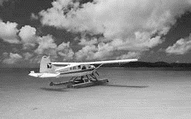
Last week lost explorers Andrew Perks, Lennon Black, Angus Smith and Jeffery Hudson have been found on the shore of a lake in Mato Grosso after an expedition to find the city of Z and Percy Fawcett went horribly wrong. Of seven only 4 were found. John Reft, Hank Reft and Zack Knight all perished in the jungle, Jeffery Hudson later died on the voyage back home. After being picked up by a seaplane -that had just delivered vaccines to a rural community- they were taken to a seaside town and put on a ship home. Two of them still are too shocked to be able to talk, now our main lead as to what happened is a diary written by Lennon black of Paisley-Scotland as he can talk but, as his wife said: “I think he’s gone mad”.
The driver of the seaplane told us: ”When I got them the were as thin as sticks and clothed in rags.”

