P1-3 Practical Maths- Measuring using our hands and feet
This week I would like you to measure some objects in your house and garden. I don’t want you to use a ruler though, I want you to use your own hand and foot prints!
First of all, you will need to ask someone to help draw round your hand or foot on a piece of paper. Carefully cut round the outside of your hand or foot print- try to make sure they are all the same size. You can decorate them if you want! You will need about 8-10 of these so you might need a bit of help making them.
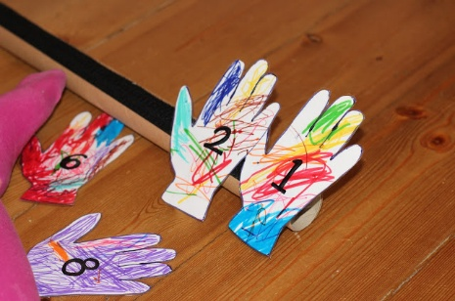
Once you have all your hand or foot prints write a number on each one. They should look a bit like this although I think your decorations will be much nicer!!

Now that you have your set of hand or foot prints you are ready to start measuring some objects!
Here are some ideas of things you could measure but you can choose to measure lots of other things in your house and garden.
- Your pillow
- Your pet
- A pair of jeans
- A welly boot
- A book
- Your favourite teddy
- A cosy scarf
- Your sofa
- The grass in your garden
- A window in your house
- Lie down on the floor and measure yourself
- Do the same for members of your family
You could make notes of how many hand or foot prints each object (or person) is and share them with us on the blog. Or take a photo of yourself being measured!
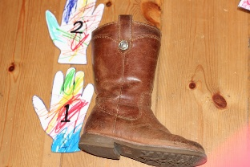
For an extra challenge- if you used handprints the first time you could repeat the activity with foot prints (or the other way around) then compare your results. You might be 9 handprints long but only 7 footprints! Have fun and I look forward to hearing how you get on with your activity on the blog!

