P1-3 weighing liquids
I hope you enjoyed your Maths scavenger hunt last week. This week I would like you to have a go at weighing out some liquids. Remember when we measure liquid, we use millilitres (ml) and litres (l). There are 3 different activities for you to have a go at- you do not need to do them all!
Activity 1- Measuring water.
Use a measuring jug to measure out different amounts of water. Look at the numbers on the side of the measuring jug to help you.
100ml

200ml

500ml

300ml

1litre

400ml

Activity 2- Problem solving- How much water?
Now it gets a bit trickier. Start with 100ml of water in your jug and follow these instructions.
Add 200ml.
Add 100ml.
Add another 100ml.
Pour out 200ml.
Add 300ml.
Pour out 100ml.
Add 200ml.
How much water do you have left?

Activity 3- Fun fruity drinks.
Try making a fun fruity drink using your measuring skills! If you don’t have the exact ingredients don’t worry- just use something else that you do have instead. Measure each ingredient in a measuring jug then carefully pour into a cup and give it a little stir. Enjoy!

Sassy sunrise-
200ml orange juice
200ml cranberry juice
100ml apple juice

Fruit scoot-
150ml orange juice
100ml lemonade or fizzy water
50ml apple juice

Fizz fantastic-
200ml lemonade or fizzy water
100ml cranberry juice
100ml apple juice

Cranberry crush-
200ml cranberry juice
150ml apple juice
50ml orange juice

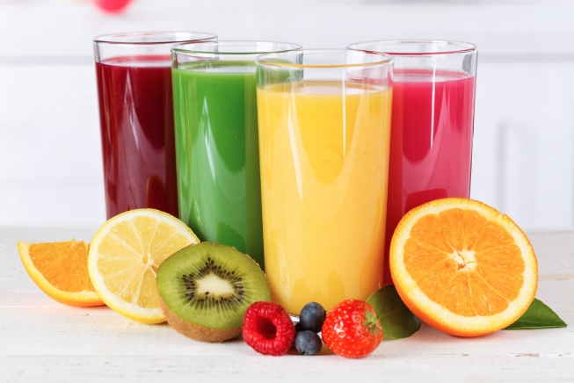
Jumping juice-
200ml apple juice
100ml pineapple juice
100ml lemonade or fizzy water

Can you make up your own fruity drink recipe? Remember to write what juice goes in it and how many millilitres you need.

