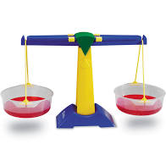
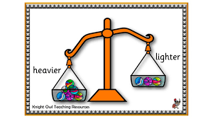
Maths scavenger hunt- weight and measure
P1-3 you might remember that on Fridays for maths we were working on weighing and measuring. We weighed things like pencils, books, our water bottles, a teddy and cubes. We also experimented to find out which objects were heavier and which objects were lighter.
Your task is to go on a scavenger hunt in your house or garden to find the objects on the list. Try to find as many as you can and tick them off the list when you find them!
Also try to use maths words like- heavy, light, heavier, lighter, heaviest, lightest, long, short, longer, shorter, longest and shortest when you are talking about the objects with your families.
I would love to see a photo or a drawing of some of the objects that you find and a little description of them on the blog.

Here is your scavenger hunt checklist-
- The lightest toy you have
- The smallest stone
- The longest leaf
- A coin
- Something which is heavier than the coin
- Something which is lighter than the coin
- A flower which is smaller than your thumbnail
- The longest pair of trousers in your house
- A piece of fruit
- Something which is heavier than the piece of fruit
- Something which is lighter than the piece of fruit
- A rock that fits in your hand
- A rock which is too big to fit in your hand
- 3 objects which make up the length of your pillow
- 4 books- put them in order from lightest to heaviest
- The widest piece of paper

