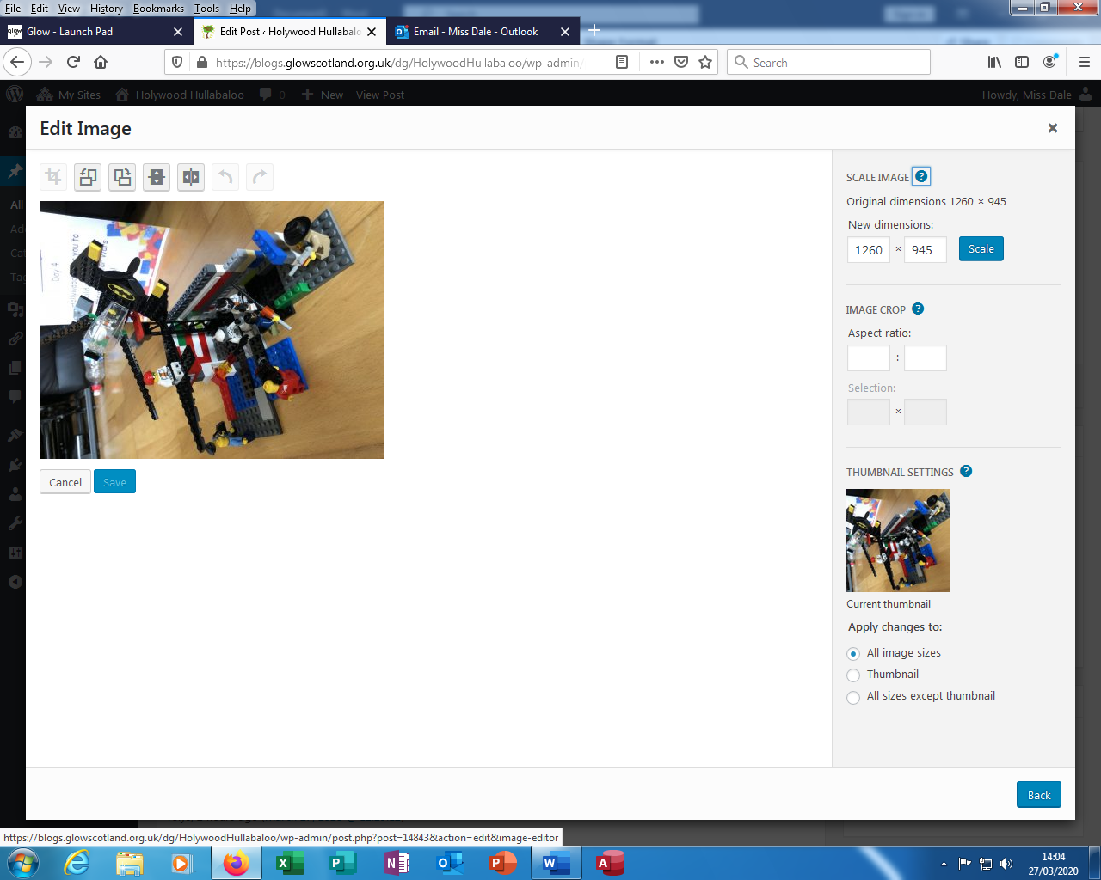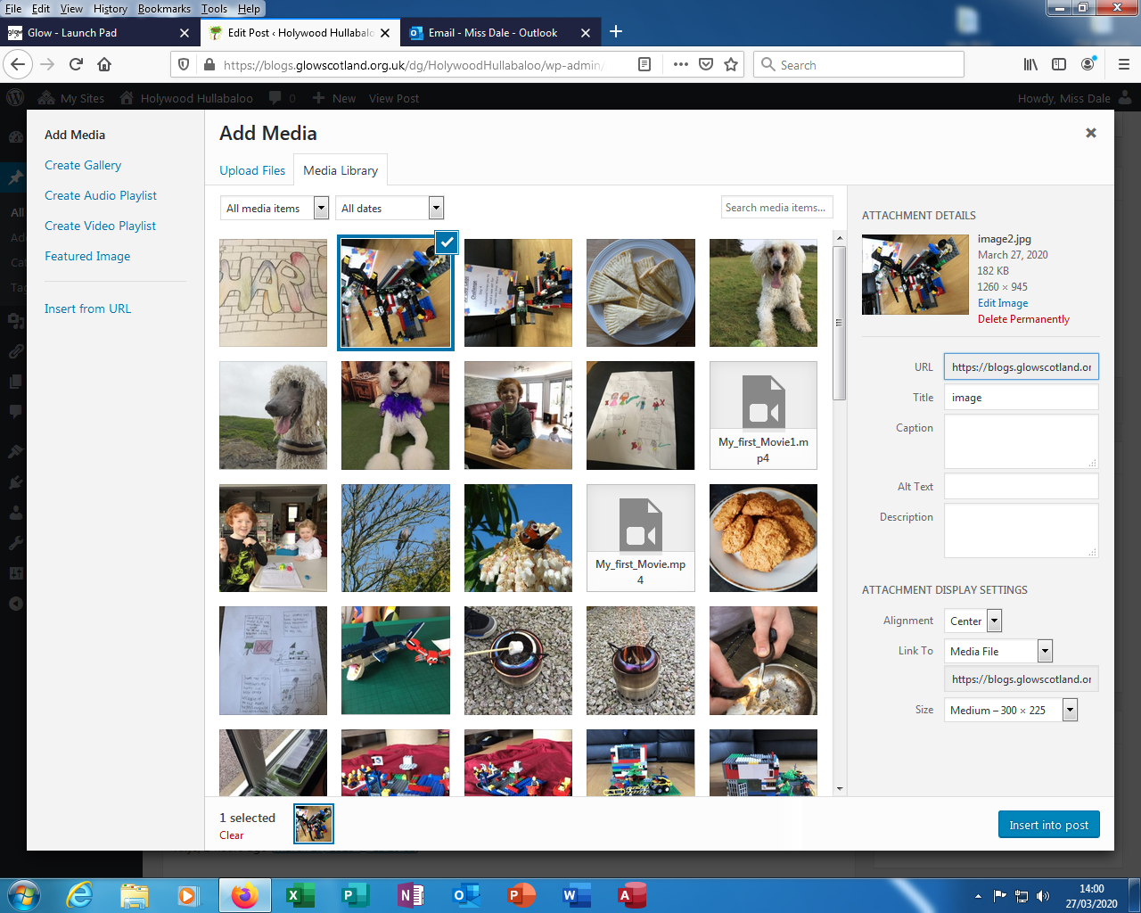

Then choose one of the rotate buttons.

When your photo is the right way up hit save.

Your photo will now be up the correct way and ready to Insert into Post.

If your photo uploads sideways.

Select it.

Hit Edit Image