 March 2013
Holywood News

Mrs Shnapp has decided it is time to go off and try new things. She has chosen to take early retirement from teaching and will finish up at Holywood at the end of next term. After working hard for Holywood School and community for over fourteen years I’m sure you will join me in wishing Mrs Shnapp well in her new adventures. Be assured we won’t let her get away without a fuss!!

School Handbook – it is now a government requirement that every school in Scotland publishes its handbook online. A copy of the school handbook can be found on the Dumgal website – www.dumgal.gov.uk
The school handbook with the Miss Dale – Mrs Henderson designed front cover can be found on the Holywood Hullabaloo Blog.
It would be appreciated if you could take a look at the new handbook(s) and give us some feedback to send in to the Education Department as changes and improvements may be needed.

Connecting Classrooms – Mrs Shnapp has succeeded in securing us funding for a second round of visits with our Kenyan partners at Obugi School. It is hoped that two teachers from the school will be at Holywood in May this year. The aim of the visit is for staff to teach our pupils and to observe and discuss learning and teaching here in Scotland.
We hope to encourage Mr Jacob Arodi the head teacher at Obugi school to send two members of his staff team who have worked hard to build the link, like Mr Steve who e-mails regularly and is teaching Obugi pupils to e-mail too.
The funding will meet the cost of air travel but very little else – Miss Dale will be hosting our visitors at her house and would be delighted if any members of the school community would like to invite our visitors to dine with them at home. A unique Scottish experience!
The visit is reciprocal and this means that two members of our school community will be travelling to Kenya in October. To reduce the impact on pupils here at Holywood the trip to Kenya will mainly fall in the school holidays in October.
A number of schools in Dumfries and Galloway are involved in partnerships with Kenyan schools and we have decided to work together to fundraise for the visits. We are currently trying to organise bag packing at local supermarkets – we hope members of the Holywood community will turn out to help pack up the shopping with us. More information to follow.

Parent Meetings – thank you for coming along with your children to discuss learning despite numerous date changes, much appreciated. Feedback was very positive and this format will now be adopted more regularly. Thank you to the five parents who returned the questionnaire sent out by the parent council, we have noted your views. Information about reporting and meeting with parents will be with you next term

School Dinner Price Increase – DGFirst are increasing the price of a school dinner to £1.75. The price increase starts after the Easter holidays.

World Religions – a whole school study
Over the next two weeks all pupils will be working in groups to study six of the main world religions. They will be researching key figures, celebrations, key beliefs and much more.
As part of their work they will set up an information stand on their given world religion at a
Celebration of Learning on Thursday 28th March at 2.30pm. Pupils will be presenting the results of their research by creating models, performing dramas and producing written texts.
We hope you can make it along to find out more!
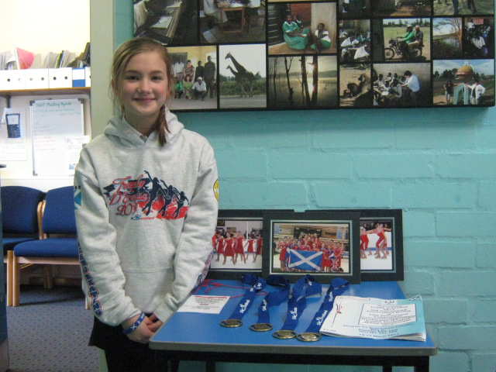

CONGRATULATIONS JENNIFER!!

Jennifer won four gold medals at the weekend as part of the synchronised ice-skating team representing Dumfries and Scotland. Jennifer competed against teams from Germany and South Africa.
Jennifer is putting together a news story about the competition and we’ll put it in the next newsletter.

Music Opportunity – Mrs Williams our Music Specialist intends to teach two different musical instruments next term. Primaries 4 and 5 will learn the tin whistle and Primaries 6 and 7 will learn to play the ukulele. Some of the school staff are taking advantage of the learning opportunity and will be learning alongside pupils. Parents are very welcome to join in too!
Please note there will be a cost involved; £4 for the purchase of a tin whistle and £16 for a ukulele. The school will try to fund the purchase of a number of instruments which we can lend – Please get in touch with Miss Dale if you wish to discuss the initiative further.

Thank You…
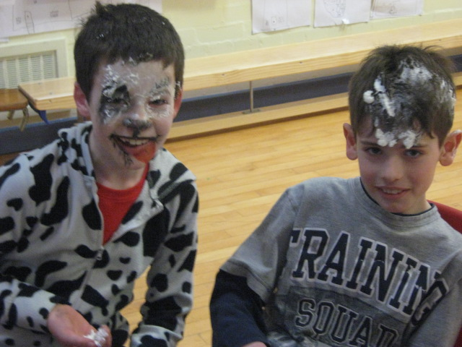

…To the Pupil Council for organising the events for Red Nose Day – a total of £109 was raised - well done everyone!

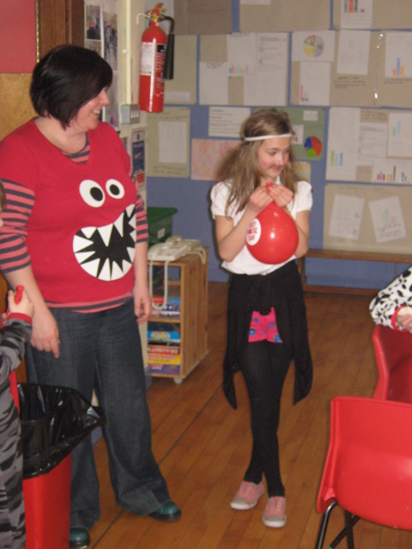
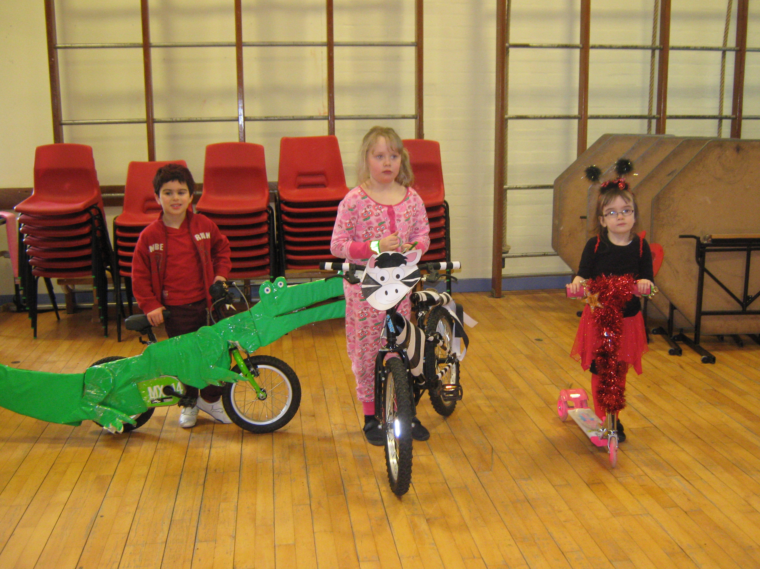
…To Mrs Templeton for rushing to Oxfam to purchase more red noses. Much appreciated.

…On behalf of Rhian Davies who was very impressed by the quality of the Blinged bikes in the P1-4 class. Family support was very clear – thank you!

Free Reading Resource – Get your child reading and listening to great books online for free. www.oxfordowl.co.uk/Findbook

Please get in touch to let us know your views.
Thank you – P.Dale

