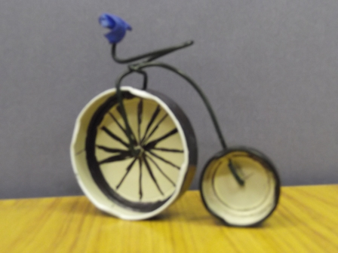
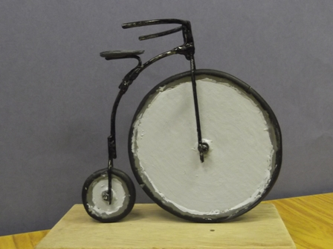
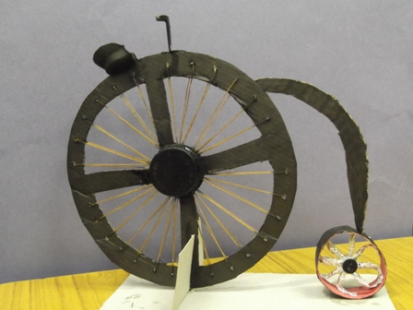
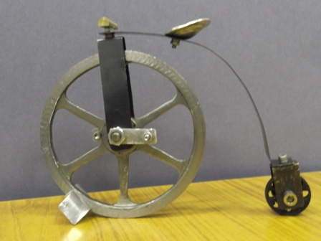
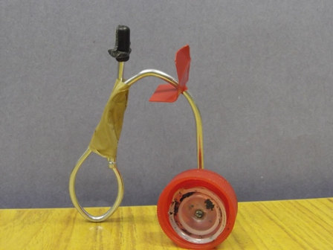
P.5,6,7 have been learning about all things VICTORIAN. Here are some of the models they made after studying the structure and formation of the penny farthing invention. A lot of maths work involving circles protractors and angles came into this work. The model making exercise was a follow-up to the maths work in class, and was set as a homework task to re-inforce skills already covered.

