[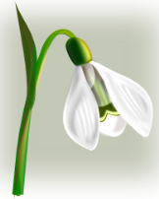](javascript:edit(26445))January 2016

|  |  |  |  |  |  |  |
| --- | --- | --- | --- | --- | --- | --- |
| Mon | Tue | Wed | Thu | Fri | Sat | Sun |
| 28 Holiday | 29 Holiday | 30 Holiday | 31 Hogmanay | 1 New Year’s Day | 2 Holiday | 3 Holiday |
| 4 Holiday | 5 Holiday | 6  School restarts | 7 | 8 | 9 | 10 |
| 11  Swimming | 12 P.1 Enrolment  Swimming | 13 P.1 Enrolment | 14  Swimming | 15  Swimming  2 P.7 pupils attending Rotary Lunch | 16 | 17 |
| 18  Swimming  7.15p.m. Parent Council | 19  Swimming  Curling Cool for P.6 and P.7  RAG BAG | 20 | 21  Swimming | 22  Swimming | 23 | 24 |
| 25 Swimming  Nursery Burns Supper  Football League 3.30-5.00p.m. | 26  Swimming | 27 | 28  Swimming | 29  Swimming | 30 | 31 |