The game of Nim

This is an ancient strategy game.

Resources Required

- 10 or 20 random objects
- Ten square

Rules
- Play in pairs.
- Count out 20 objects and place two objects in each square.
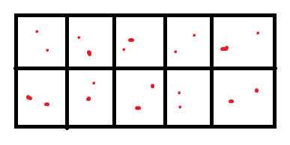
- Take turns to remove 1, 2 or 3 objects from the ten square until one object is left.
- If it is your turn to pick up this object then you have lost the game.

Have discussions around tactics, whether it makes a difference who goes first, what happens if more people join in the game
and so on.

