Multiplication Hopscotch
This game can be adapted for indoors or outdoors.

What you need:
- sidewalk chalk or number card/ paper torn into pieces.
- Rock, stone, any small object
- a set of multiples to practice (any times tables)

Rules
- Depending on what your child(ren) are working on you can write (or have them write) the multiples of a number in the squares or you can write the multiplication facts on the squares. E.g.
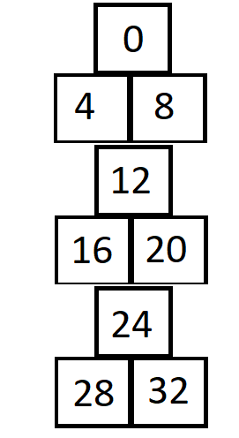

- Using your pebble, stone or small object, through it to land on any of the squares. Depending on where it lands the child counts up to that number reciting the times table. For example if it landed on 20, the child would hop and say 4 x 1 is 4, 4 x 2 is 8, 4 x 3 is 12, until they reached. Then they would go again, this can be done with someone else or on there own. To make to more fun and engaging you can throw the stone, pebble or object for the person you are playing with.
- If you are playing this indoors, simply make small bits of paper with the multiple on it, and follow the same rules.
Try it with as many different Times tables as you like.

