Why Does the Ocean Have Waves?

The ocean is never still. Whether observing from the beach or a boat, we expect to see waves on the horizon. Waves are created by energy passing through water, causing it to move in a circular motion. However, water does not actually travel in waves. Waves transmit energy, not water, across the ocean and if not obstructed by anything, they have the potential to travel across an entire ocean basin.
Waves are most commonly caused by wind. Wind-driven waves, or surface waves, are created by the friction between wind and surface water. As wind blows across the surface of the ocean or a lake, the continual disturbance creates a wave crest. These types of waves are found globally across the open ocean and along the coast.
More potentially hazardous waves can be caused by severe weather, like a hurricane. The strong winds and pressure from this type of severe storm causes storm surge, a series of long waves that are created far from shore in deeper water and intensify as they move closer to land. Other hazardous waves can be caused by underwater disturbances that displace large amounts of water quickly such as earthquakes, landslides, or volcanic eruptions. These very long waves are called tsunamis. Storm surge and tsunamis are not the types of waves you imagine crashing down on the shore. These waves roll upon the shore like a massive sea level rise and can reach far distances inland.
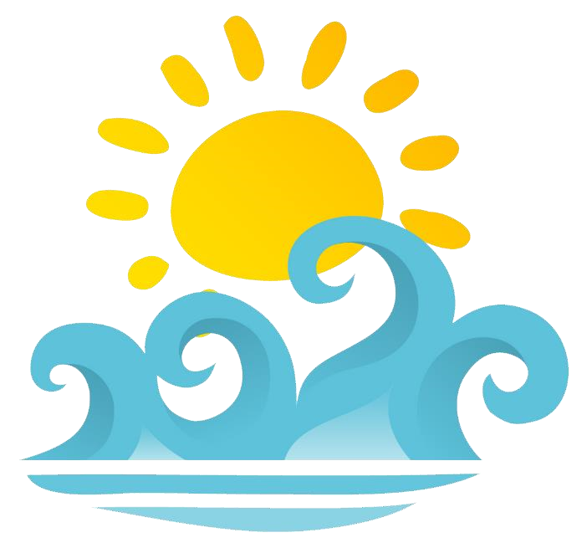
The gravitational pull of the sun and moon on the earth also causes waves. These waves are tides or, in other words, tidal waves. It is a common misconception that a tidal wave is also a tsunami. The cause of tsunamis is not related to tide information at all but can occur in any tidal state.

Questions:
- What creates waves?
_______________________________________________________
_______________________________________________________

- What could be an obstruction to waves?
_______________________________________________________
_______________________________________________________

- Why do you think wind is the most common cause of wave creation?
_______________________________________________________
_______________________________________________________

- What are some causes of hazardous waves?
_______________________________________________________
_______________________________________________________

- What is another name for a certain type of wave?
_______________________________________________________
_______________________________________________________

