Outdoor or Indoor Assault Course | Rainbow Scavenger Hunt | Garden/House Orienteering | Natural Noughts and Crosses
Build an assault course using anything you can find to use as obstacles. You can add activities too like “when you get to the stepping stone do 10 star jumps”. Be creative! Using a timer, have a race with your family members to see who can complete it fastest. | Go outside in the garden or for a walk, and collect something or a few things for each colour of the rainbow. | Draw a birds eye map of your garden and/or your house. Ask someone in your family to hide a few small objects and mark them with an X on the map. Can you find the objects? | 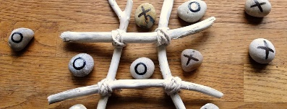  Create a noughts and crosses board and pieces out of natural materials and ask someone to play with you. One idea is using painted stones and sticks.
Marble/Tennis Ball Run | Campfire/BBQ | Build a Shelter/Den | Build a Shelter/Den for an Animal
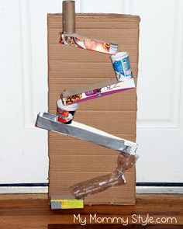  Using any materials you can find, make a track or a run for either a marble or a small ball to travel along. Your run must have at least 2 different heights, change direction at least once and the marble/ball must roll all the way to the end. | Have a camp fire or a BBQ in the garden with your family. Toast some marshmallows or heat some burgers.  OR  Sing a campfire song (you can use Youtube to learn one).  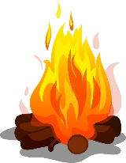 | Go to the woods during your daily exercise time. Use materials you can find to build a den large enough to fit 2 people. Can you make it waterproof?  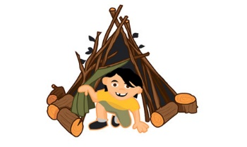 | In the woods or your garden, can you make a home for a woodland creature of your choice? (mouse, rabbit, bird…)  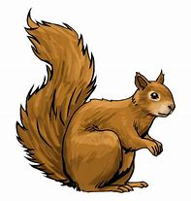  Use natural materials you can find and some string. Can you make it waterproof? Can you add any furniture?
Pitch a Tent in the Garden | Midnight Feast | Go for a Cycle/Scooter Ride | Go on a Nature Hike
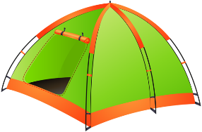  Pitch a tent in your garden and spend a bit of time in it. You could even sleep in it if the weather allows! When you’re finished, you’ll need to take it down and pack it away too. If you don’t have a tent or a garden, build a den in your house instead! | Plan and prepare a healthy midnight feast. This can be shared with others in your house. | Go for a cycle or scooter ride with a member of your family.  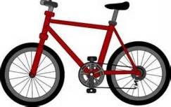 | 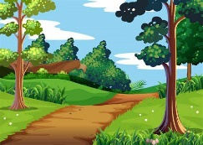  Go for a walk around a local park or green space. See how many types of plants and insects you can find.  Good places to look for insects are under large rocks or tree stumps.  Take photos or draw what you find.
Tallest Natural Structure | Natural Art Picture | Make and Fly a Kite | Make a Bird Feeder
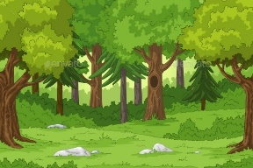  Go to the woods and try to make the tallest standing structure you can using only natural materials you find and some string. | 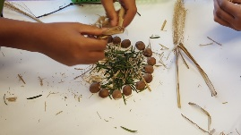  Collect some natural materials from the garden or while you are out on a walk. Use them to create a piece of artwork. | Design and make your own kite using any materials you like! Can you make it fly on a windy day?  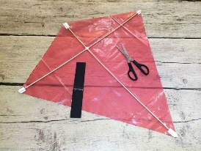 | 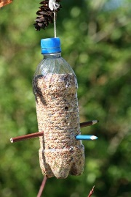  Design and make your own bird feeder. Some ideas are using a hollowed out orange or a plastic bottle. You’ll find lots of designs on the internet.  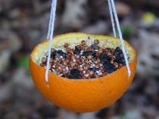
Make A Packed Lunch | Blindfold Challenge | Learn a new skill | Make A Mini Raft
Plan and make your own packed lunch – try to include one item from each food group.  Take a photo and post it to our Teams  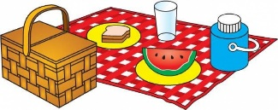 | Create an obstacle course in your house or garden, or find a safe space outdoors. Put on a blindfold and ask a member of your family to guide you around the obstacle course. Then swap over.  Alternatively, you could put a bucket somewhere and ask someone to guide you to the bucket to put a ball inside.  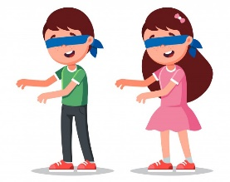 | Choose something you’d like to learn how to do. It must be something you can’t already do!  Some ideas might be making a bed (putting duvet cover etc on), learning a new Tik Tok dance, learning to sew/knit, juggling, build a card tower, ride a bike, whistle.  Take some time to learn your new skill then reflect on your progress. Write/talk to someone about what you learned, what you found easy/difficult, why you chose to learn that, how you feel now that you can do it etc.  Share what you learned on our Teams page – a sentence or a photo would be great! | Make a mini raft for a toy using any materials you like. (Sticks and string would be a good example). Test it in the sink/bath/bucket of water. Does it float? Does it take the weight of the toy? (Choose a toy you don’t mind getting a bit wet!)  